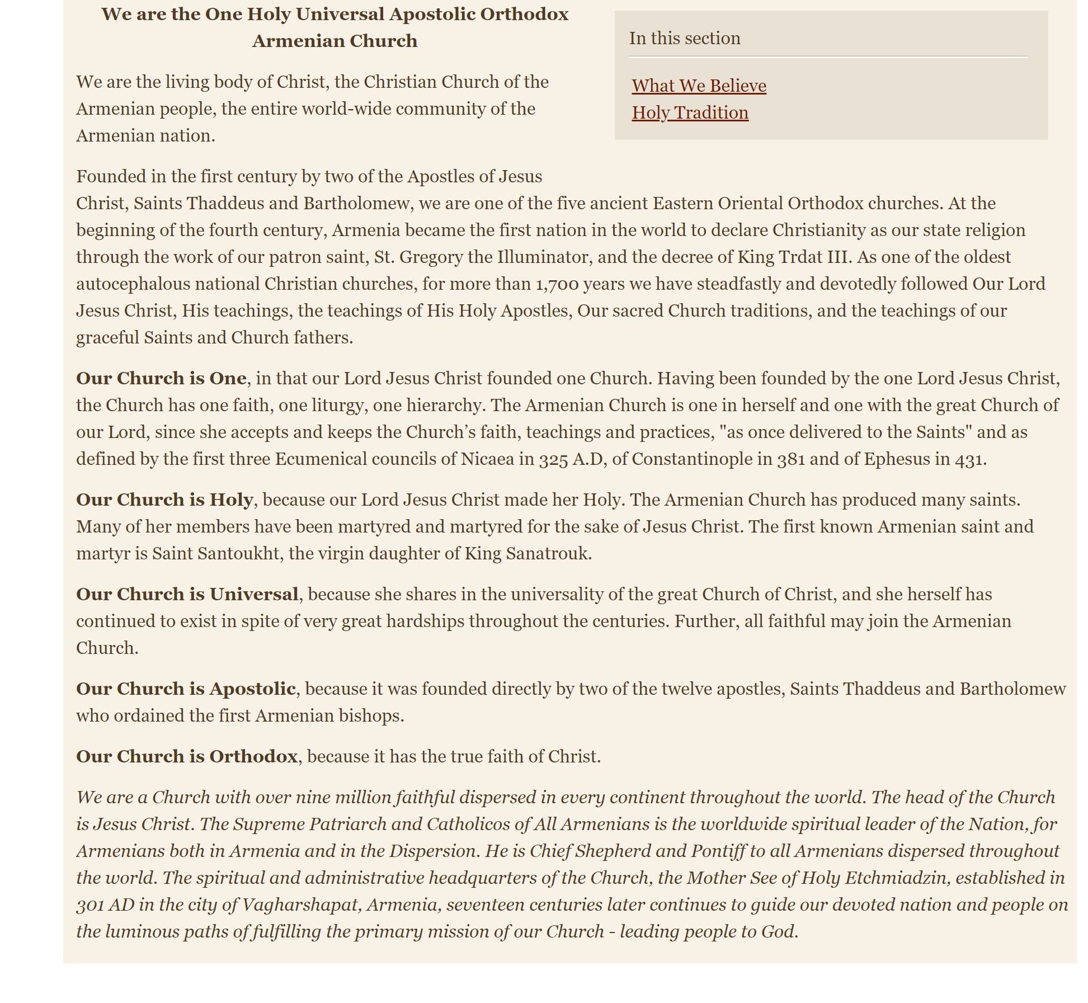
From the Website of the ArmenianChurch.org Mother See of Holy Echmiadzin

