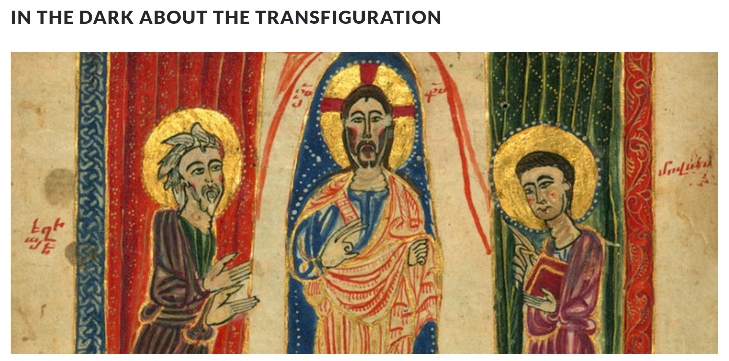

Taken from Vemkar (Eastern Diocese) June 2024

YOUTUBE

Bread and Salt: Make a Splash 5:05

https://youtu.be/DWOb2nPGD5o