**Scripture and Feast Day Notes**

**Sunday, July 8, 2018**

**From Today’s Readings**

**Wisdom 7:25-8:4** Solomon extols the virtues of wisdom, having sought her from his youth: she is a powerful source of renewal, prevails against evil, and draws us to friendship with God since “God loves nothing so much as the person who loves wisdom.” (v. 28) *Discussion: In 1 Kings 3: 1-15, God asks Solomon what he wants most. Rather than long life or wealth, he asks for wisdom. What do* you *want most? How might “wisdom” be the best answer to that question?*

**Zechariah 14: 16-21** Declaring that a day is coming when the Lord will be king over the whole earth, the prophet foresees that all -- even former enemies of the faith -- will be called to Jerusalem on the Feast of the Tabernacles to celebrate and worship Him as the Lord Almighty. *Discussion: “Holy to the Lord” will be inscribed on the horses’ bells and on cooking pots (v.20) on that day of the Lord. What parts of* your *life do you feel are inscribed to the Lord?*

**1 John 1:1-7** John proclaims the truth of Jesus Christ based on all he has seen, heard, and touched so that others “may have fellowship with us” (v. 3) and in turn with God. God is light and walking in that light means living by the truth and loving God and one another. *Discussion: In what ways have you, like John, “seen,” “heard,” and “touched” Jesus?*

**Matthew 16:13-17:13** This rich account, worthy of a long summation, begins with the important conversation at Caesarea Philippi when Jesus asks “Who do people say I am?” After hearing the answers (John the Baptist, a prophet), He asks “and who do *you* say I am?” To which Peter famously replies “You are the Christ, the Son of God.” In the next account, Jesus predicts His death and counsels that anyone who follows Him must take up his cross as well for “those who want to save their life will lose it”. Finally, we read the account of Jesus’ transfiguration (see below). *Discussion: Jesus asked His disciples a question that was meant for* all *His followers and for all time: Who do* you *say He is? Who is He in* your *life?*

**Feast of the Transfiguration**

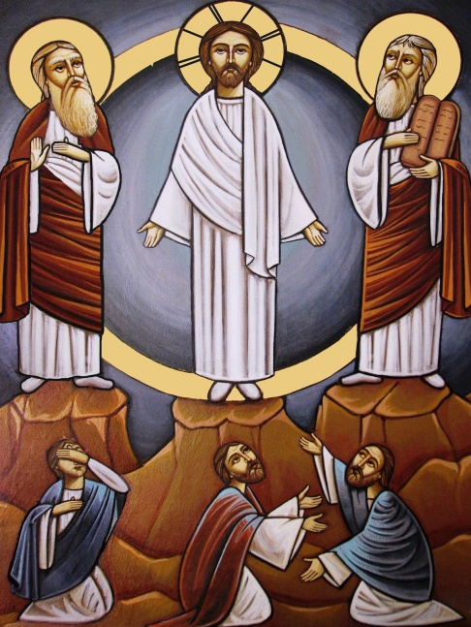The Transfiguration, one of the five major feasts of the Armenian Church, marks the extraordinary occasion Jesus took His three closest disciples, Peter, James, and John, up to Mt. Tabor where He was “transfigured,” appearing radiant. The prophet Elijah and the patriarch Moses appeared at His side, symbols of the Law and Prophecy which Jesus had come to fulfill. A voice from heaven was heard saying: “This is my beloved Son.”

Some customs of an ancient Armenian pagan festival for the goddess Asdghig are still associated with this feast, such as decorating the church with roses or flowers (and therefore the Feast’s name *Vartavar;* it is more formally called *Aylagerbootyoon* or *Baydzaragerbootyoon)* and spraying one another with water.

*Department of Christian Education*

*Diocese of the Armenian Church of America (Eastern)*

[*elisea@armeniandiocese.org*](mailto:elisea@armeniandiocese.org)