**Scripture and Feast Day Notes**

**Third Sunday after Transfiguration**

**From Today’s Readings**

**Isaiah 5:1-10** The Song of the Vineyard is a famous parable of disobedience and disappointed love. The song tells of a man who lovingly plants and tends to a vineyard, building a watchtower and a winepress and waiting for the bounty of wine-worthy grapes. Yet he finds only wild grapes, symbols of a willful Israel and Judah, and warns of the ruin that will come to pass. *Discussion: God asks His people what more He could have possibly done (v.4) for them to bear worthy fruit. How would you assess the spiritual fruit in* your *life?*

**1 Corinthians 6:18-7:11**St. Paul exhorts his listeners to shun sexual immorality and respect their bodies as temples of the Holy Spirit. He reminds husbands and wives that their bodies belong to each other and that where there are difficulties, reconciliation should be sought. *Discussion: We are not our own – we are God’s, bought at a price! (6:19-20) How does this faith fact change how you look at your body? At the ways you might be abusing it with excess?*

**Matthew 19:3-12** The Pharisees challenge Jesus with the question of divorce. He responds by referring them to the creation of marriage as recounted in Genesis where “two become one” – an indissoluble sum. Speaking against the ease with which men legally terminated their marriages at the time, Jesus preached the importance of the marriage covenant. *Discussion: The Armenian Church acknowledges divorce and remarriage although a second wedding ceremony carries a penitential message. As He so often did, Jesus was posing a radically different approach to covenants –honor them! And while marriages where there is abuse, addiction, chronic infidelity, etc, require serious intervention, many marriages might be redeemed with committed effort. What do you think? Could the high divorce rates of today’s world benefit from Jesus’ hope?*

**Feast Day of St Athanasius (and St. Cyril)**

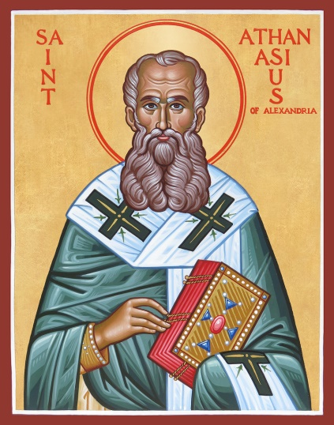One of the great champions of orthodoxy, Athanasius was born in Alexandria in 296 and died there in 387. Serving as personal secretary to the Patriarch, he attended the Council of Nicaea in 325 and spoke eloquently against the heresy of Arius (who denied Christ’s divinity in declaring that He was created by the Father). This controversy was the most important issue facing the Church. Athanasius eventually became Archbishop of Alexandria succeeding his mentor and worked tirelessly against Emperors and policies that were hostile to Christians. In one of his best-known works *On the Incarnation,* he famously describes God as an artist whose lovingly rendered portrait of humankind, made in His own image, is stained over time (through sin). “The subject of the portrait has to come and sit for it again and then the likeness is redrawn…Even so was it for the All-holy Son of God. He, the image of the Father, came and dwelt in our midst, in order that He might renew humankind made after Himself…”

*Department of Christian Education*

*Diocese of the Armenian Church of America (Eastern)*[*/elisea@armeniandiocese.org*](mailto:/elisea@armeniandiocese.org)