**Scripture and Feast Day Notes**

**Third Sunday After Theophany**

**From Today’s Readings**

**John 6:39-47** Jesus continues to teach the crowds that have eagerly followed him to Capernaum. One can imagine the impact of His electrifying message: that He was sent from heaven by the Father so all who believe in Him might have eternal life! To the Jews’ grumbling that the simple son of Joseph and Mary could not be the Son of God, Jesus draws from their own history, asserting that unlike the manna from heaven which eased the Jews’ hunger only briefly, He was the eternally-nourishing “bread that came down from heaven.” (v.41; 49-50)*. Discuss/reflect: Imagine yourself one of the crowd that day. What are you hearing? What are you seeing all around you? Then these words reach your ears: “I am the bread that came down from heaven…whoever eats of this bread shall live forever.” What do you think?*

**2 Timothy 2: 15-19**Timothy, entrusted with the Christian community in Ephesus, is counseled by his mentor Paul to avoid “godless chatter” - those who indulge in it grow only more ungodly. St. Paul refers to some who are spreading wrong teachings; believers must turn away from this. He reminds Timothy that God knows the hearts of those who follow Him *Discuss/reflect: What does “godless chatter” mean to you? What damage can it do?*

**Isaiah 62:1-11** Heralding a renewed love relationship with His holy city, the Lord presents Himself as the bridegroom to a restored Jerusalem. The Hebrew for “Deserted” and “Desolate” (v. 4) are commonly used for a wife whose husband has forsaken her and a childless woman respectively, so all of this imagery points to a now happy, fruitful ‘marriage.’ Its citizens will be protected by “His mighty arm” (v. 8) and enjoy the fruits of their labor in joyful peace. *Discuss/reflect: What qualities of the marriage covenant also describe God’s relationship with His people? With you?*

**Saturday, February 5: The sons and grandsons of St. Gregory the Enlightener**

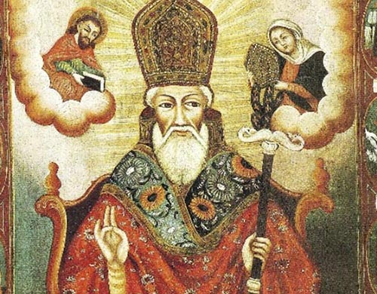How extraordinary that St. Gregory not only changed the hearts of a nation and therefore its entire history by evangelizing Armenia, but then gifted it with not one but two generations of dedicated Christian servants. His two sons (by wife Miriam), Sts. Aristakes and Vertanes and Vertanes’ sons Sts. Krikoris and Hoosig, were deeply devoted to Christ in the spirit of their illustrious father and grandfather. Aristakes succeeded his father as Catholicos and also attended the First Ecumenical Council at Nicaea in 325 A.D. Vertanes then succeeded his brother as Catholicos in 333. He in turn was followed by his son Hoosig, a vigorous defender of the faith against the ruling family; a dispute with his father-in-law King Diran led to Hoosig’s martyrdom in 347. Krikoris was a tireless evangelizer in Armenia’s neighbors, Georgia, and Caucasian Albania where he was martyred. An amazing dynasty of champions for Christ! *Reflection: What do you think it takes to plant the zeal for Christ in the next generation?*

*Department of Christian Education/ Diocese of the Armenian Church (Eastern)*[*/elisea@armeniandiocese.org*](mailto:/elisea@armeniandiocese.org)*.*