**Sunday School Teachers’ Scripture and Feast Day Weekly Memo**

**Third Sunday After Theophany**

**From Today’s Readings**

**John 6:22-38** *Awestruck by Jesus’ miracle of feeding a large crowd with just a few loaves and fish, people eagerly seek him. To their questions, Jesus answers that he offers more than physical sustenance. He tells them* he *is the true bread from heaven in the famous words: “I am the bread of life; he who comes to me will never go hungry.”* Discussion: Bread is a symbol for the physical food we need to live. What kind of hunger do you think Jesus is talking about when he says we will “never be hungry again?” What hungers distract you from life’s deeper meaning? How might prayer and faith help?

**2 Tim 3:1-12** *Timothy describes a future of false teachers who might appear godly and yet their behavior will reveal their character. (v. 8: Jannes and Jambres were Egyptian court magicians at the time of Moses, false teachers themselves.)* Discussion: Do the disagreeable qualities listed in vv 2-4 figure in today’s world? Are there times you might display a “form of godliness” (v 5) without the inner heart for God?

**Is 63:7-18** *Almost Psalm-like in structure, these verses recall God’s saving actions in the past (such as the Exodus), acknowledge the sin of Israel, and end with a plea for mercy.* Discussion: Make a list of the saving actions with which God has gifted *you*.

**St. Sarkis the Warrior (4th century)**

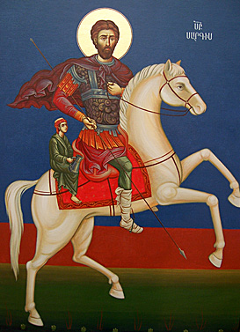Sarkis was a valiant and faithful soldier of Greek descent in Emperor Constantine’s army. When Emperor Julian took the throne in 361, he began to vigorously promote traditional Roman paganism instead of the Christian faith legitimized by Emperor Constantine in 313. This earned him the title “Apostate.” Under threat of persecution, Sarkis, with his son Mardiros (depicted seated behind his father) sought the protection of King Tiran of Armenia. From there, he went to serve in the Persian army, where he and his son won many converts to Christianity. When he refused to worship pagan idols, both he and his son were martyred. Sarkis believed that telling people about Jesus was more important than his life in this world. He died witnessing to Jesus. Fourteen Persian soldiers whom he had converted to Christianity risked their lives to bury the general’s body and they too were executed. In the fifth century, Mesrob Mashdots moved the saint’s remains to Armenia.

*Department of Christian Education*

*Diocese of the Armenian Church (Eastern)*

[*elisea@armeniandiocese.org*](mailto:elisea@armeniandiocese.org%0d%20%20ericv@armeniandiocese.org)