**Scripture and Feast Day Notes**

**Sixth Sunday After Theophany**

**From Today’s Readings**

**John 7: 37-52** Teaching the crowds at the Feast of the Tabernacles, Jesus calls upon those who thirst to come to him and drink so that “living water” might flow within them (meaning that they will be filled someday with the Holy Spirit). People debate whether this is indeed the Messiah. When the temple guards are chastised by the priests for not arresting him, they declare in awe: “No one ever spoke the way this man does.” (v.46) Nicodemus, who knew and respected Jesus, asks for a fair hearing of what Jesus has to say. *Discuss/reflect: How amazing that those hired to keep Jesus from inciting the crowd, have themselves been shaken by His words. Read these verses again, reflecting prayerfully on what Jesus says. What moves* you?

**Titus 1:1-11** St. Paul writes to his protégé Titus, declaring himself to be a servant of God for a “faith and knowledge resting on the hope of eternal life.” (1:2) Having entrusted Titus to continue building up the community in Crete, he advises him to appoint elders and outlines their required virtues. Without even-temperedness, honesty, self-control, discipline and a clear sense of what is holy and true, they will not inspire confidence and loyalty. *Discuss/reflect: In St. Paul’s list of leadership virtues, it’s not about what you* do; *rather it’s about what kind of person you are borne out by how you live. What might this teach you about following Jesus?*

**Is 63:18-64:12** The people of God lament (how many times, oh Israel!) what once was and is no longer, as they endure defeat and hardship. Blaming their own sinful indifference to their “awe-some” God, they beg His intervention. *Discuss/reflect: Verse 7 might well be directed to us in pandemic times. What makes people indifferent to their God? How can* you*” lay hold” of Him?*

**St.Ghevont and St. Vartan**

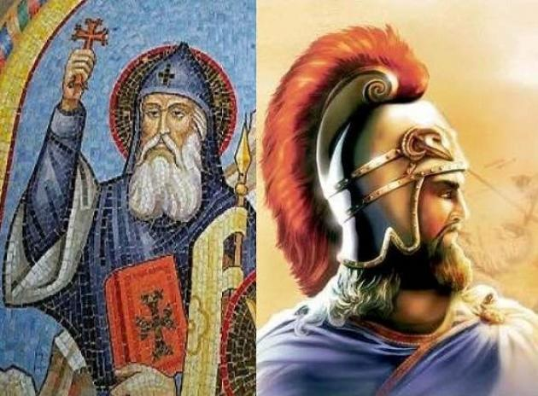Why are these feast days so important to Armenians? Together they center on the Battle of Avarayr in 451 A.D, the war the Persians waged against the Armenians after their vain attempt to oppress them under Persian rule and religion. The Armenians were hugely outnumbered (reportedly 60,000 Armenians against 200,000 Persians excluding the armored elephant brigade) in this first recorded battle in defense of Christianity. Under the leadership of their commander-in-chief, Vartan Mamigonian, they fought valiantly. Fr. Ghevont was General Vartan’s advisor, serving as what might be called today the army chaplain. Before the battle, he inspired the army with a deeply moving sermon and went among the soldiers, encouraging them, and distributing Holy Communion. In response to his fervent evangelizing, St. Ghevont was later taken to Persia and martyred along with the other priests. Perhaps these men, the soldiers, their wives, daughters and sisters, all represent hope in the face of impossible hardship and oppression, a hope born of Jesus Christ, a hope driven by heavenly goals that go so beyond “winning” it is hard for the average person to comprehend. But not for the saints… *Reflection: Today, pray for the souls of all who fell at Avarayr. Ask God for the courage to follow Christ and live your faith boldly, without hesitation.*

*Dept of Christian Education/Diocese of the Armenian Church of America (Eastern)*/[*elisea@armeniandiocese.org*](mailto:elisea@armeniandiocese.org)