**Scripture and Feast Day Notes**

**Fourth Day After Theophany**

**From Today’s Readings**

**Luke 1:26-38** The angel Gabriel gives Mary miraculous news: highly favored and beloved by the Lord, she would give birth to the Son of God. He was to be named Jesus, the Son of the Most High, and would reign over Jacob’s descendants; His Kingdom would never end. How could this possibly happen? “Nothing is impossible with God.” That’s all Mary needed to hear. So be it, was the essence of her humble response (v 38). How like the words of Jesus in the of Garden of Gethsemane (Luke 22:42): “Not my will but yours be done.” Even before we see it modeled by Jesus Himself, we witness the trust and obedience of Mary. Only Luke presents us this aspect of the Holy Mother: first disciple, true servant, model Christian. *Discuss/reflect: The art world teems with images of the Annunciation. Mary is often pictured reading a book in a serene setting. We can imagine the rush of wings, the angelic radiance that overwhelms the young girl. Read these verses, pausing to see, smell, hear the scene. How is Mary’s faith an example to you?*

**John 1:1-17** “In the beginning” were the first well-known words of another chapter of the Bible: Genesis. Just as in the Creation account, here we also read of light overcoming darkness, of God’s Word, once breathing Creation into life, and now the Son of God become flesh - Jesus as the living word of the Father sent to reveal Him. To all who believed, He extended an invitation to become children of God. The law may have come through Moses, but grace and truth came through Jesus. *Discuss/reflect: Prayerfully read John’s reverent, loving description of his Lord. Go back and read the phrases and words that tell you about who Jesus is.*

**Galatians 4:1-7** Paul describes a child as no different than a slave, remaining subject to guardians until he is of age. Similarly, we were once children, subject to the world’s guardianship until, in the fullness of time, the Son of God was born into human history and we became fully vested sons and daughters. Through Jesus and the Holy Spirit, our hearts are filled to bursting with God’s presence and we can only cry out “Father!” We are no longer children, but heirs to all His astounding promises. *Discuss/reflect: The word “abba” (4:6) expresses tenderness. How affectionate is your relationship with God?*

**Thursday, January 13: Feast of the Naming of our Lord**

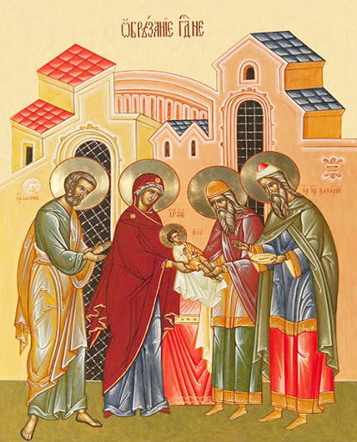In Luke 1:31, the angel Gabriel tells Mary that her child is to be called Jesus. The name Jesus is related to both the Hebrew and Aramaic, meaning “he will save” or “savior.” This was the name given to the Holy Child by the angel Gabriel (conveying God’s message) even before He was conceived. His official naming (Luke 2:21) took place on the eighth day on the occasion of His circumcision, in keeping with Hebraic law, and is commemorated by the Church on January 13. We celebrate the naming because it heralds Jesus’ very purpose and mission as Savior and Redeemer. *Reflection: While your name might not have a specific meaning, God “calls” us all by name to live a sacred life, defined by our unique gifts as well as our exalted, redeemed nature.Much is said today about “living your truth,” but are you living God’s truth?*

*Department of Christian Education/Diocese of the Armenian Church of America (Eastern)*[*/elisea@armeniandiocese.org*](mailto:/elisea@armeniandiocese.org)