**Scripture and Feast Day Notes**

**Fourth Sunday After Theophany**

**From Today’s Readings**

**John 6:15-21** The disciples row across the Sea of Galilee to join Jesus where he has withdrawn after teaching and feeding thousands. As happens often on this body of water, a storm arises suddenly. Rowing desperately, they see Jesus walking towards them on the water. They are terrified of the sight, but He calls out to them reassuringly: “It is I; do not be afraid.” Jesus joins them in the boat and they safely reach land. *Discuss/reflect: These times remind us that our lives are not unlike the disciples’ boat – we sail along fully equipped with sails and oars and yet sudden storms render these useless. Allow this powerful story of our Lord as master of the wind and the waves to comfort you. Place your fear in His almighty hands and let Him safely guide you to where “you are heading.” (v.21)*

**2 Tim 2:15-26** Continuing to advise his protégé (see last Sunday’s Scripture Notes for vv 15-19), St. Paul asks Timothy to be a holy vessel, useful for the Lord’s purposes; to flee youthful desires that can lead one astray; and to avoid ‘stupid arguments’ by responding kindly and without resentment. To counter false teachings, he recommends instructing people gently. *Discuss/reflect: What an excellent moment in time to be reminded of the futility of “stupid arguments” and the importance of kindness! Pray that this advice governs your own behavior.*

**Is 61:10-62:9** Isaiah 61 sings of the restoration of the Jews (returning from exile and despairing of rebuilding their city and community to its former glory) as people of God. They will now be clothed in metaphorically appropriate clothing - in “garments of salvation” and “robes of righteousness.” (v.10) These images appear in the Armenian rites of baptism and ordination as well as in the priest’s vesting prayers before the Divine Liturgy. (See last Sunday’s Scripture Notes for vv 62:1-9) *Discuss/reflect*: *“I delight greatly in the Lord; my soul rejoices in my God” says the renewed people of God. (61:10) Can you say the same? Start all your prayers this week with this verse from Isaiah. Sing it!*

**February 12: St. Sarkis the Warrior**

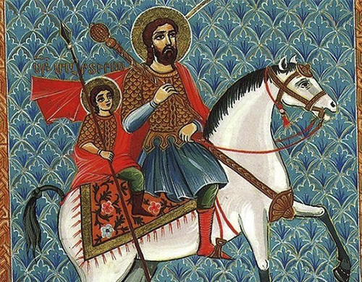“Warrior” might seem a curious word for describing a saint! And yet the imagery of spiritual warfare is deeply biblical. There were also many soldiers and generals (St Vartan) who fought for their faith, standing firm and courageous for Christ. Sarkis was a soldier of Greek descent in Emperor Constantine’s army. When Emperor Julian took the throne in 361, he began to zealously promote traditional Roman paganism instead of the Christian faith legitimized by Emperor Constantine in 313. This earned him the title “Apostate.” Under threat of persecution, Sarkis and his son Mardiros sought the protection of King Tiran of Armenia. From there, he went to serve in the Persian army, where he and his son won many converts to Christianity. When they refused to worship pagan idols, father and son were martyred. Fourteen Persian soldiers whom Sarkis had converted to Christianity risked their lives to bury the general’s body and they too were executed. In the fifth century, Mesrob Mashdotz moved the saint’s remains to Armenia. *Reflection: In what ways can you be a“warrior for Christ”? Dept of Christian E ducation/ Diocese of the Armenian Church/(Eastern)/*[*elisea@armeniandiocese.org*](mailto:elisea@armeniandiocese.org%0d%20%20ericv@armeniandiocese.org)