**Sunday School Teachers’ Scripture and Feast Day Weekly Memo**

**Fourth Sunday After Theophany**

**From Today’s Readings**

**John 7: 37-52** *During the important Jewish Feast of the Tabernacles, Jesus has been teaching the crowds and the Temple authorities. He speaks of the “living water” that will flow from those who believe in him (meaning that they will be filled someday with the Holy Spirit). People asked one another if he was indeed the Christ.* Discussion: Why did the guards feel so powerless to stop Jesus from speaking (vv 45-47)?

**Titus 1:1-11** *St. Paul advises his protégé Titus to discourage wrong teachings and to carefully consider the qualities of those appointed elders of the community.* Discussion: What are the qualities St. Paul considered important to those who lead a Christian community? (vv 6-9; note St. Paul refers to leaders as husbands and fathers since church elders then were usually married.) Why do you think these qualities are important in a leader?

**Is 63:18-64:12** *Israel continues its frank admission of sinfulness and pleads for God’s merciful intervention.* Discussion: How does Isaiah characterize God in vv 5-7? (*As One who always supports those who “gladly do right and remember His ways” but who will seem hidden from those who “never call on His name or strive to seek Him.”*) Between these two poles, where is God in *your* life?

**St.Ghevont and St. Vartan**

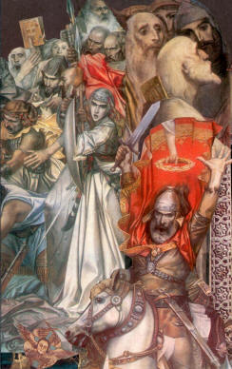The Feast of St. Vartan and the 1,036 Martyrs (*Vartanantz*) commemorates the Battle of Avarayr in 451 A.D. This was the war the Persians waged against the Armenians after attempting in vain to oppress them under Persian rule and religion. The Armenians were hugely outnumbered (60,000 Armenians against 200,000 Persians excluding the armored elephant brigade) in this first recorded battle in defense of Christianity. Under the leadership of their commander-in-chief, Vartan Mamigonian, they fought valiantly. Although the battle was lost, it paved the way for the religious freedom that was conferred not long afterwards.

Fr. Ghevont was General Vartan’s advisor, serving as what might be called today the army chaplain. Before the battle, he inspired the army with a deeply moving speech and went among the soldiers and encouraged them, holding the cross of Christ in his hand and distributing Holy Communion. St. Ghevont was later taken to Persia with other clergymen and in response to his fervent evangelizing, martyred along with the other priests. His memory is celebrated two days before *Vartanantz,* on the feast day known as *Ghevontyantz*.

*Department of Christian Education*

*Diocese of the Armenian Church of America (Eastern)*

[*elisea@armeniandiocese.org*](mailto:elisea@armeniandiocese.org%20%0dericv@armeniandiocese.org)