**Sunday School Teachers’ Scripture and Feast Day Weekly Memo**

**First Sunday after Theophany**

**From Today’s Readings**

**John 2: 1-11** *Jesus attends a wedding in Cana with his mother and disciples; at Mary’s humble prompting, Jesus performs what John describes as the first of his miraculous signs, all of which will point to deeper meanings. Turning water into wine, our Lord made available a symbol not only of celebration and life but a foreshadowing of the sign of the New Covenant. Most importantly, this “best” wine speaks of the abundant life that Jesus offers (typically, hosts would water down the wine as the evening waned since revelers would not know the difference).* Dis-cussion: How could the presence of Jesus heighten the sense of joy and celebration in *your* life?

**1 Timothy 1: 1-11**  *St. Paul urges Timothy to take a strong position on the false teachings that abound in Ephesus. He reminds the young missionary that faith is not about rules and regulations but is about (v.5) the love that comes from “a pure heart and a good conscience and a sincere faith.” This inner relationship of faith and life echoes the gospel charge that “by their fruits you shall know them.” (Matthew 7:16)* Discussion: What specific ways might a sincere faith change what you think, do, or say?

**Isaiah 54: 1-13** *The prophet joyously proclaims God’s love for his people, described as the relationship that exists between a husband and a wife. Marriage, abandonment, and restored relationship are strong Old Testament themes (see Hosea or the Song of Hannah in 1 Samuel 2). Underlying the metaphor of marriage is the idea of covenant, a binding mutual commitment, as well as deep personal love.* Discussion: If you thought of your relationship with God as one of a deeply loving commitment, (think perhaps of the dearest loved one in your life), what might such a relationship entail? (More time spent with God? Doing what would please God? Etc.)

**Feast of the *Naming of Jesus***

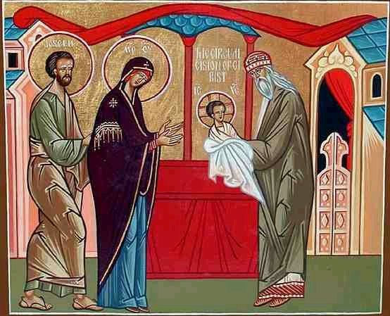In Matthew 1:21 and in Luke 1:31we read about two extraordinary messages delivered by the angel Gabriel. In Matthew, the angel appears to Joseph in a dream saying that the name of the child Mary would bear was to be Jesus. In the Gospel of Luke, the angel tells Mary that her child would be called Jesus. The name *Jesus* is related to both the Hebrew and Aramaic, meaning “he will save” or “savior.” His official naming (Luke 2:21) took place on the eighth day on the occasion of the circumcision, in keeping with Hebraic law. (Jesus was not named Jesus Christ at the time of his birth. The word Christ is a title and means “the anointed one” or “the Messiah.”) We celebrate the naming because it heralds Jesus’ purpose and mission as Savior and Redeemer.

*Department of Christian Education*

*Diocese of the Armenian Church (Eastern)*

[*elisea@armeniandiocese.org*](mailto:elisea@armeniandiocese.org)