**Sunday School Teachers’ Scripture and Feast Day Weekly Memo**

**Sunday of the Unjust Steward**

**From Today’s Readings**

**Luke 16: 1-31***See below for the Parable of the Steward (1-13). Today’s reading also includes the renowned story of the unnamed rich man and Lazarus. The rich man ignores the poor and ailing Lazarus and after both have died, he sees that Lazarus is in heaven at Abraham’s side. Lamenting his own torment far from God, he asks that Lazarus be sent to warn his brothers of what can happen when they live selfish lives. Abraham tells him they had already been well informed by the Law and the prophets so nothing more could help.* Discussion: What do you think Jesus means when he says “No one can serve two masters” (13)? What “masters” pull you away from God? What makes it so difficult for people to be convinced of God’s ways?

**Ephesians 4:17-5:14** *St. Paul notes that ‘children of light’ must set aside past behaviors, having become renewed in Christ and created to be like God in true holiness (vv.23-24). The way of love excludes all the vices we might have once considered acceptable.* Discussion: What specific ways does St. Paul cite as examples of “new self” behavior? (25: *speak truthfully, 26: let go of anger quickly, 28: engage in useful work so we’re able to help others, 29: speak to build others up, 31: do not be bitter, or angry or slander others, 5:1: imitate God, 2: live a life of love, 3: avoid sexual immorality or any kind of impurity or greed, 7: avoid the people who encourage you to behave immorally.)* Of those listed, what one behavior do you need to change? Pray for God’s help.

**Isaiah 56:1-57:21** *God’s message is simple: “do what is right!” (56:1) He exhorts His people to remove the obstacles that keep people from Him and to be faithful to His covenant and honor the Sabbath, welcoming all who do the same.* Discussion: Is your parish community welcoming to outsiders? Does your church family or your Sunday worship service present obstacles for someone of another background?

**Sunday of the Steward**

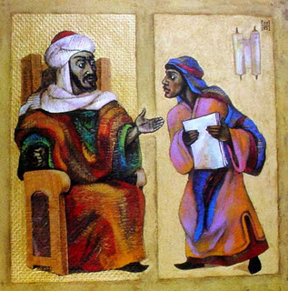Stewards oversaw the finances and all the affairs of the house for wealthy families of ancient times. The steward in this parable (often translated as the “shrewd manager”) is far-sighted about his own welfare. When his master accuses him of wasteful ways, demanding an accounting and threatening his dismissal, the steward reduces the moneys owed to his master by others so that they might employ him should it come to that (he was actually lowering his own built-in commission in every negotiation). He is commended by the master. Although a challenging parable, it is easier to understand when we see that Jesus is asking us to be as diligent and ambitious about our spiritual welfare as we are about our worldly security (8-9).

*Department of Christian Education*

*Diocese of the Armenian Church of America (Eastern)*

[*elisea@armeniandiocese.org*](mailto:elisea@armeniandiocese.org)