**Sunday School Teachers’ Scripture and Feast Day Weekly Memo**

**Sunday of the Prodigal Son**

**From Today’s Readings**

**Luke 15: 1-32***Among the wonderful parables of losing and finding (sheep, coins), the story of the Prodigal Son tells of a young man who leaves home for what he thinks will be a better life. Defeated by his own selfishness and sin, he humbly returns to his father who joyfully greets him. His obedient older son is sullen – why the party for a prodigal? This is a parable about the nature of God’s merciful love and the true rewards of being faithful.* Discussion: Describe both sons. Why was the older son resentful? What didn’t he understand about his own faithfulness? (*It meant he was gifted with the pleasures of life at home, the joy of being with his father day in and day out, just as we can choose to be obediently in the* Father’s *presence day in and day out…)* Primary grades: Tell the story and ask students to draw pictures as you go along. You can assign different parts of the story and create a storyboard.

**2 Cor. 6:1–7:1** *St. Paul humbly shares the character of his ministry, which is a “mixed bag” of good and bad - glory and dishonor, sleepless nights and rejoicing, “having nothing but possessing everything.” He advises believers to strengthen one another in a shared life.* Discussion: What might it mean for someone to be poor but make others rich, have nothing but possess everything? (v.10)

**Isaiah 54:11-55:13** *God will restore Jerusalem to a beauty and value that is described with images of precious jewels; He continues to promise His people all that they require to be satisfied.* Discussion: Read 55:2 aloud. Reflect. Repeat these verses in your own words. On what do you invest your money and your labor that proves ultimately unfulfilling?

**Sunday of the Prodigal Son**

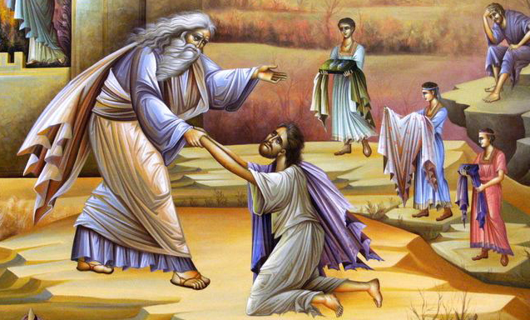The first two Sundays of our Lenten journey depicted happiness (Paradise) and then loss (the Expulsion).With this week’s parable we experience both. Much like Adam and Eve, the younger son in this parable is not happy with what he has. He wishes for the pleasures of a “distant country.” So he leaves his father and his home, descends into suffering and despair and then returns, chastened by the discovery that *he had left behind what was best.* The father reminds the resentful older brother -- as the Father reminds us -- that true happiness is in living with him daily and that all who return “home” are joyfully received. It is a cliché that we never appreciate the things we have – good health, meaningful work, loving friends and family – until we lose them. Jesus’ parables always transform such simple, well-understood realities into powerful metaphors for God’s love. *With whom do you identify in this story and why? The loving father? The son who makes mistakes and then returns home?The older brother who resents the reward given to a repentant sibling?*

*Department of Christian Education*

*Diocese of the Armenian Church of America (Eastern)*

[*elisea@armeniandiocese.org*](mailto:elisea@armeniandiocese.org)