**Scripture and Feast Day Notes**

**Sunday after Transfiguration**

**From Today’s Readings**

**Isaiah 3:16-4:1** In God’s judgment on Judah and Jerusalem, Isaiah has already sketched the breakdown of social order. He now focuses on the women, whose finery and beauty – representing a culture of luxury and pride – he describes in detail. All will be removed and defiled as punishment. *Discussion: Do you see this “haughty” (v.16), self-centered attitude reflected in men and women today? In what ways does our consumer culture perpetuate the importance of outer beauty?*

**1 Corinthians 1:25-30**St. Paul reminds the faithful that it was not because of their superb qualities that they were called to faith, rather God calls people out of their foolishness, their unimportance, their weakness, to a strength and widsom that can be found only in Jesus Christ. *Discussion: What do you think Paul meant when he says that the foolish and lowly things will shame the wise and strong (v 27)? Have you seen this principle at work in the world?*

**Matthew 18:10-14** In the preceding verses, Jesus has identified a child – a being without any legal status or rights – as an example to His disciples of the kind of open-hearted, unfettered faith that will be the greatest in the kingdom of heaven. He continues with the story of the 100 sheep, confirming that the Father cares for them all fiercely and equally; He will leave the 99 and look for the one lost sheep, celebrating joyfully when it is found. *Discussion: With whom do you relate in the story of the lost sheep? Are you one of the 99, contentedly grazing with fellow believers? The one who wandered off? If the latter, what would bring you back?*

**Feast of St. Cyprian the Bishop**

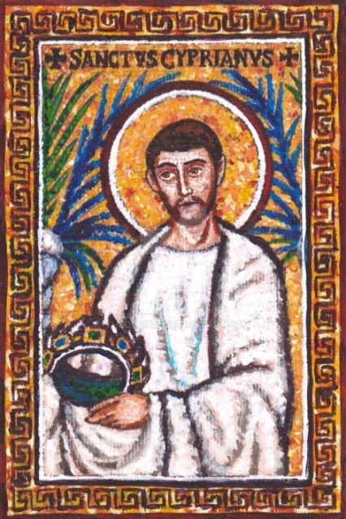St. Cyprian (c. 200-258) was a courageous leader at a time of terrifying oppression in the early church. Born to wealthy Roman-African parents, he was a lawyer and teacher of rhetoric before converting in middle age. He quickly rose through the ordained ranks to become Bishop of Carthage (near modern-day Tunis) in North Africa, eventually shepherding a scattered and desperate flock during the Decian persecutions. As a result of these and other attacks against Christians, a crisis developed concerning those (referred to as the “lapsed”) who had succumbed to Roman torture and sacrificed to pagan gods and now wanted to be received back. Taking a moderate stand, Cyprian wrote his renowned treatises *On the Fallen (De Lapsis)* and *On the Unity of the Catholic* [meaning universal] *Church.* He also bore heroic witness to his faith during a plague-induced famine, personally tending to the sick, burying the abandoned dead, and prompting wealthy locals to help the poor. He was eventually martyred. In his important *Treatise on the Lord's Prayer* Cyprian writes “My dear friends, in these few words there is great spiritual strength, for this summary of divine teaching contains *all* of our prayers and petitions.” *Reflection: It was once, and continues to be in some places in the world, a matter of life or death to freely express one’s Christian faith. Is* your *faith in Jesus Christ worth dying for? How about simply* living *for?* *Department of Christian Education*

*Diocese of the Armenian Church of America (Eastern)*[*/elisea@armeniandiocese.org*](mailto:/elisea@armeniandiocese.org)