
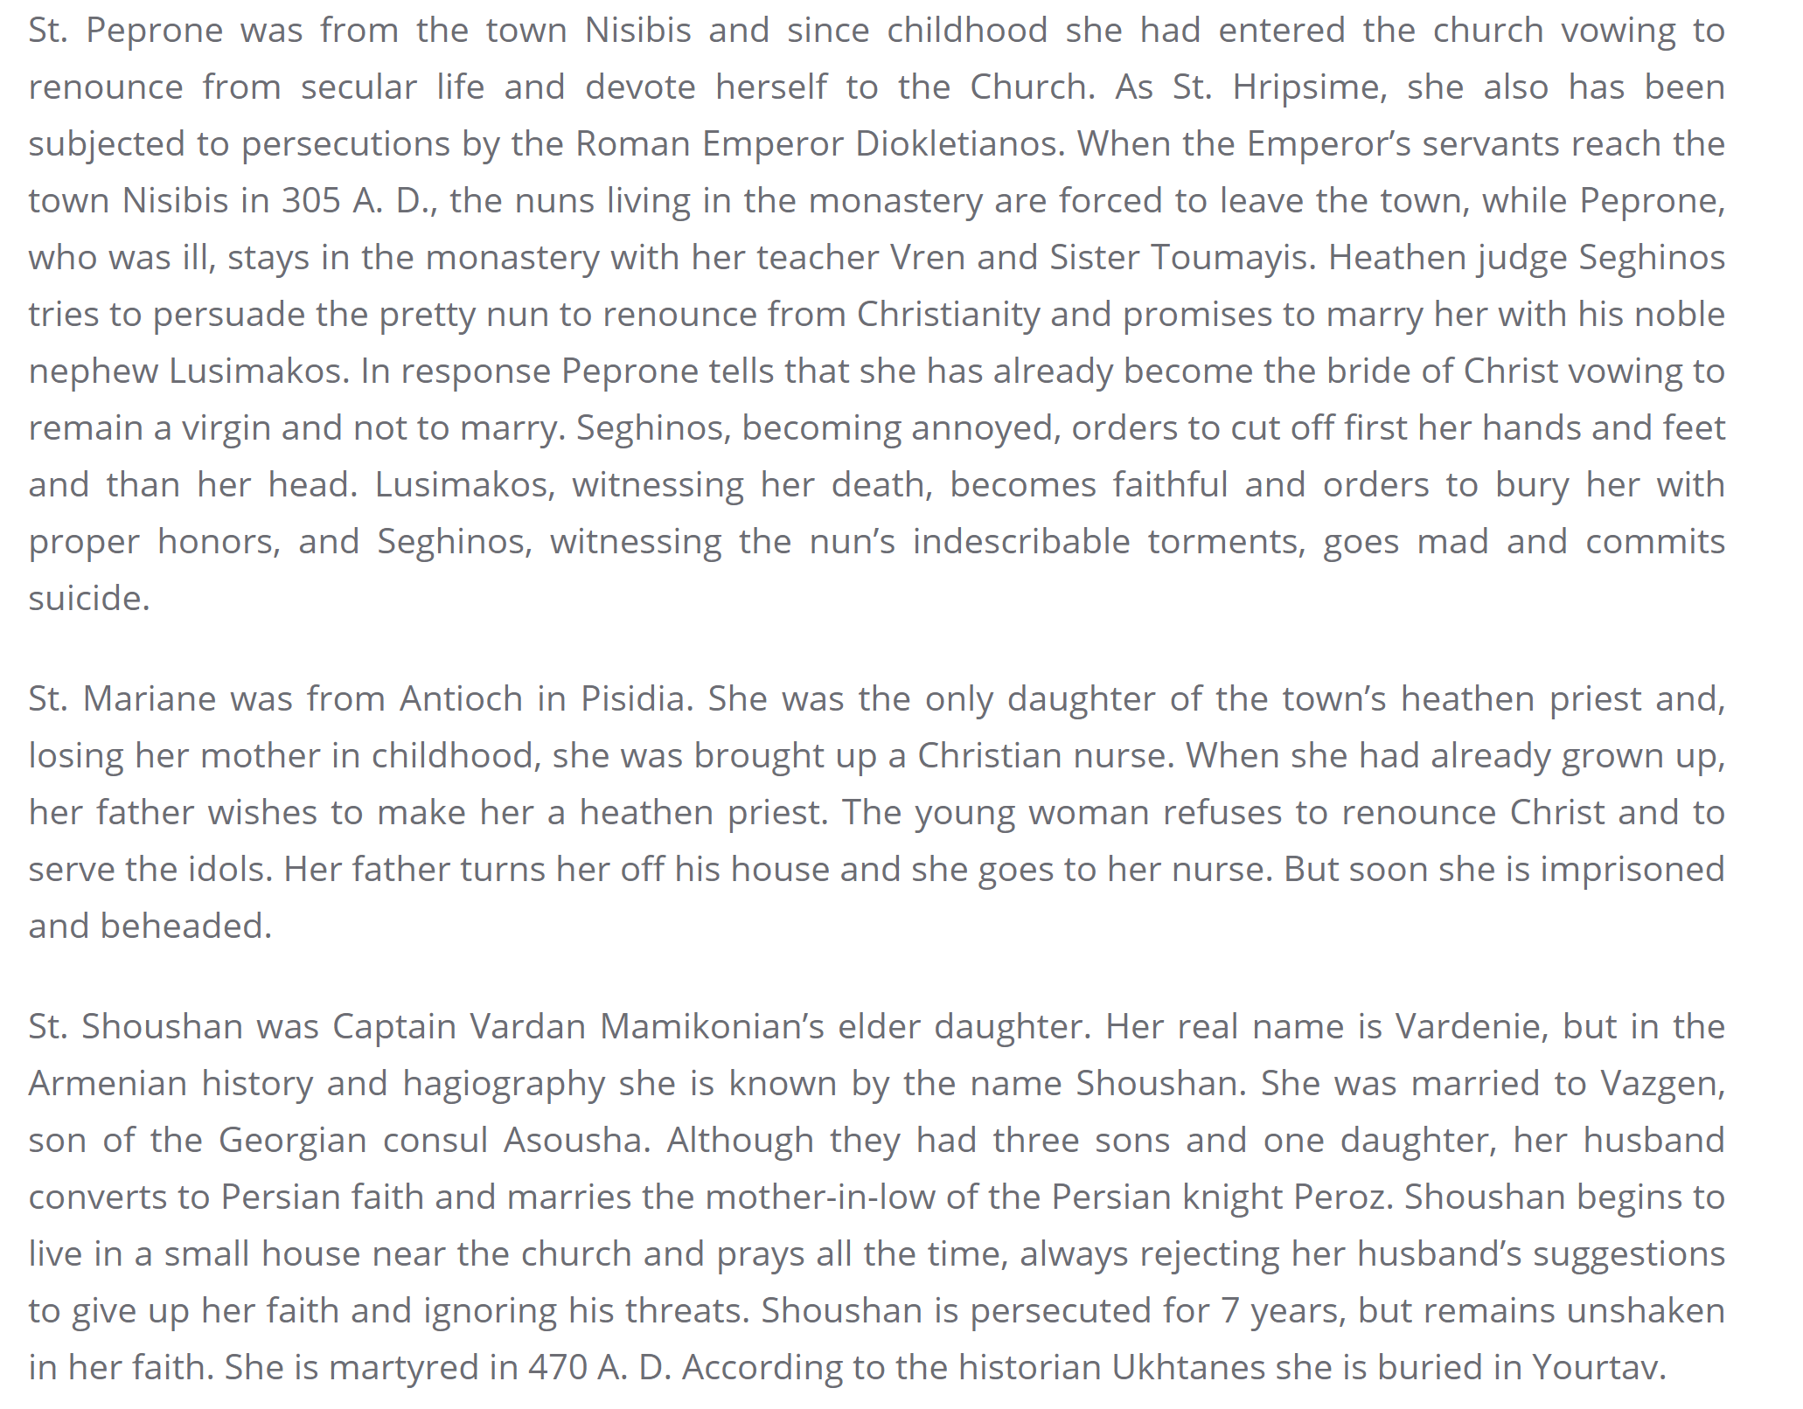

From the website of the Diocese of Armenian Apostolic Orthodox Holy Church in Georgia

