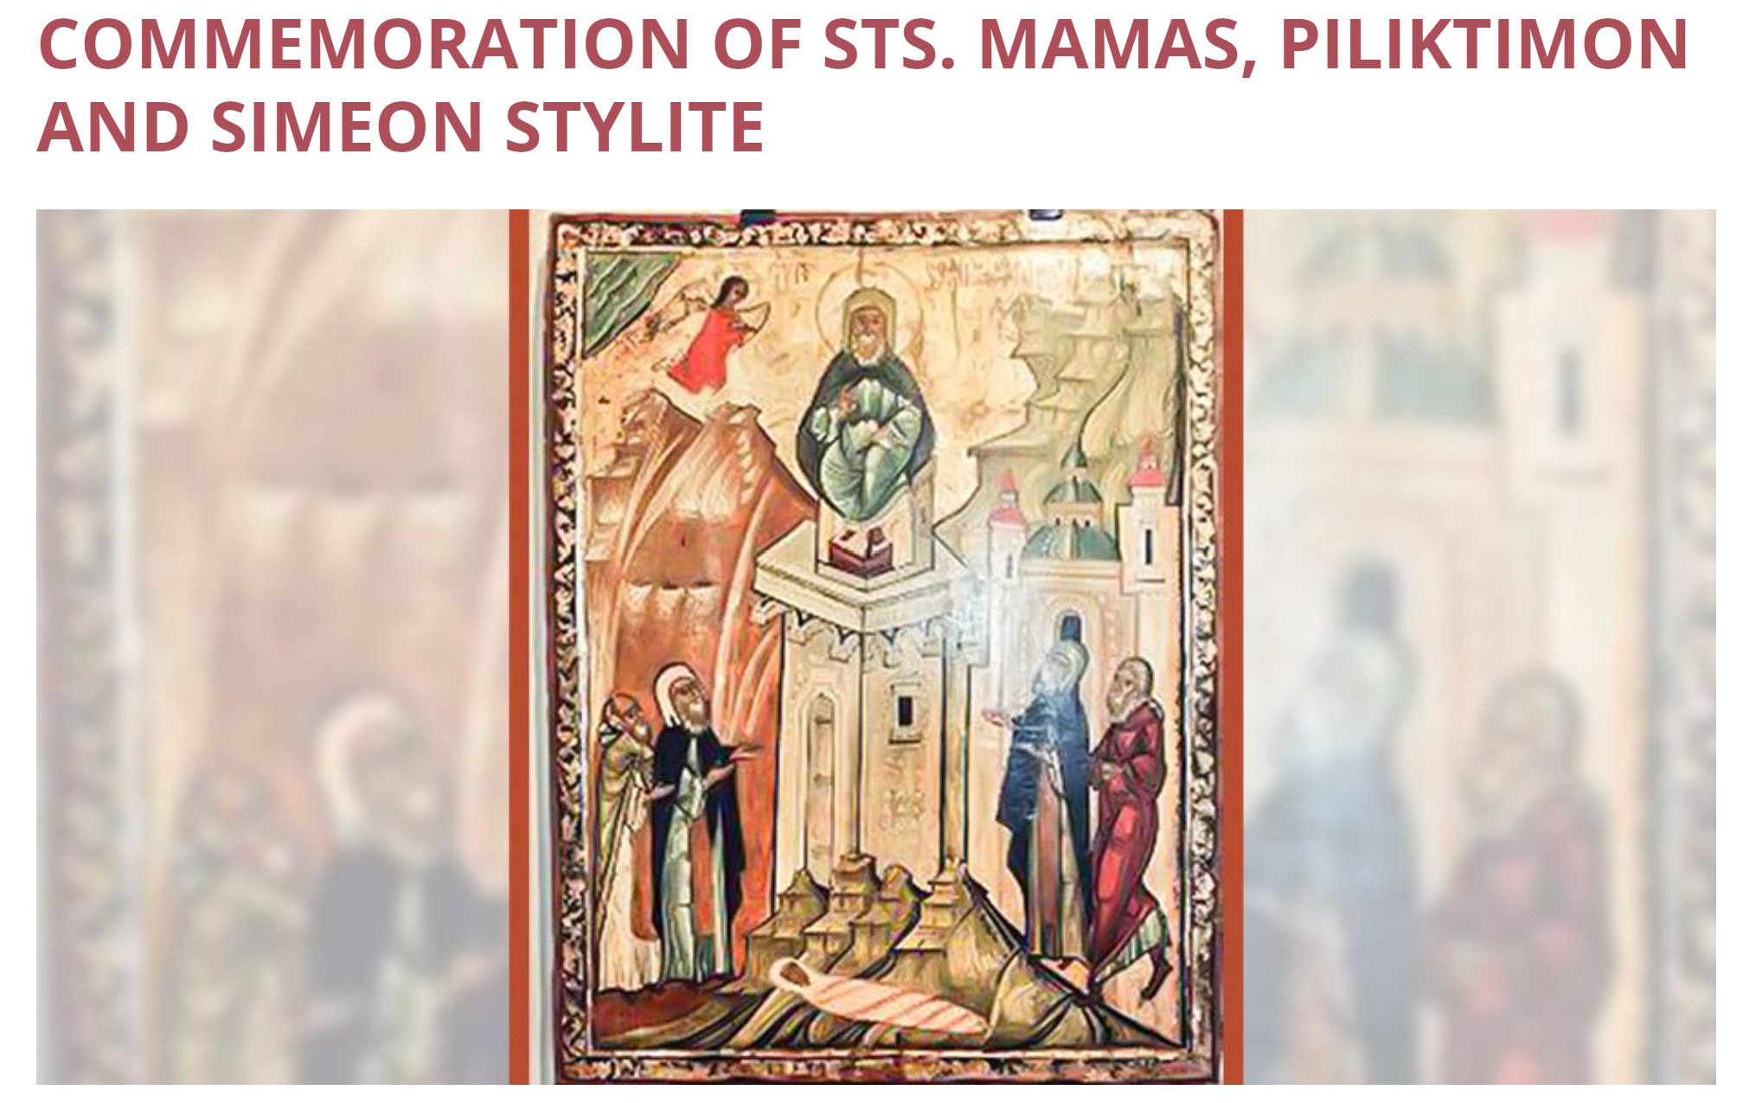
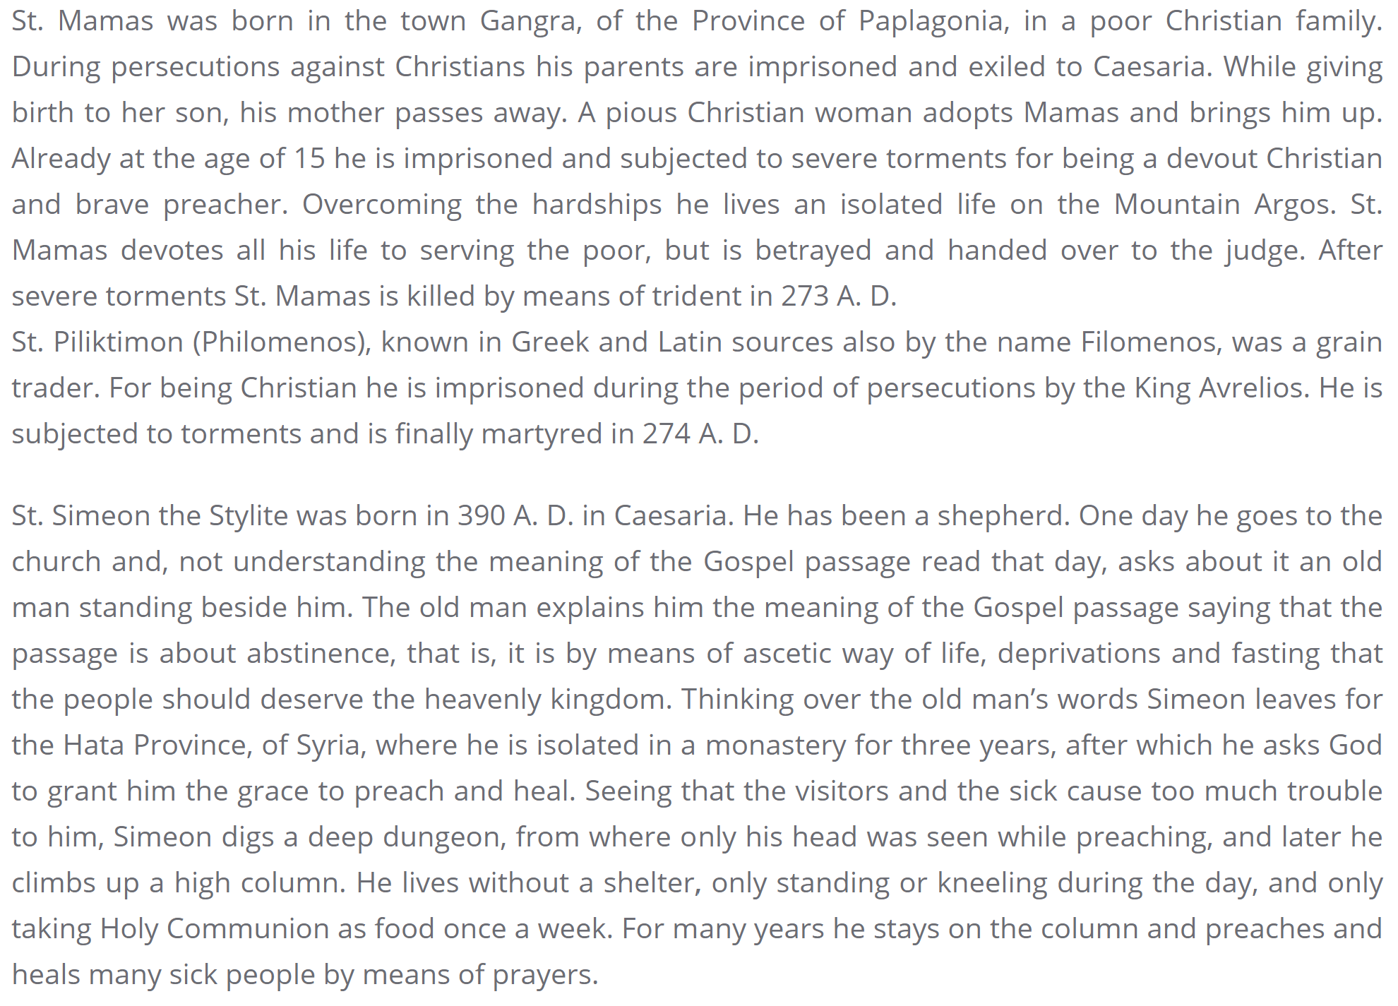
9-23-24,9-22-25, 9-21-26, 9-20-27, 9-25-28, 9-24-29, 9-23-30

From the website of the Diocese of the Armenian Apostolic Orthodox Holy Church in Georgia

