
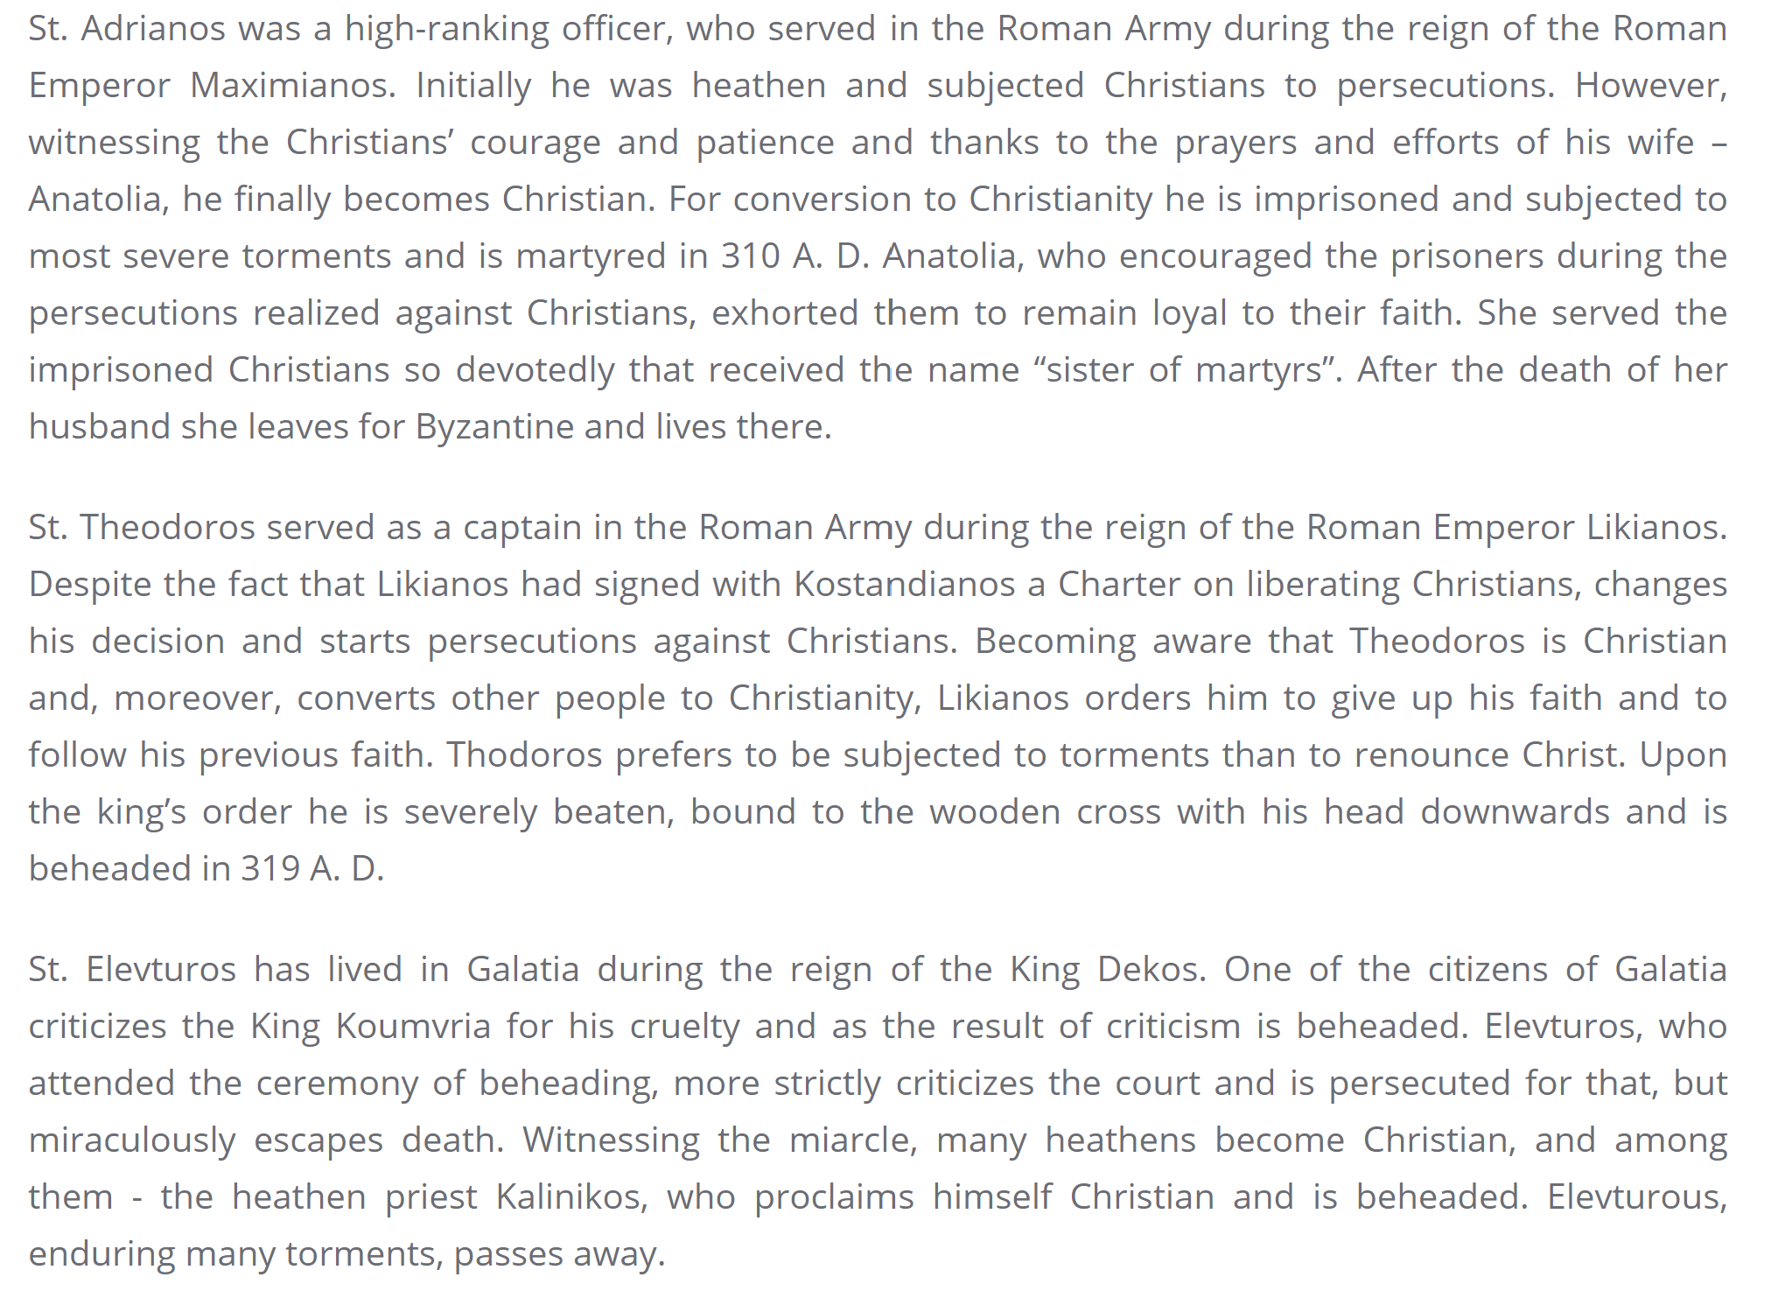

From the website of the Diocese of the Armenian Apostolic Ortodox Holy Church in Georgia

