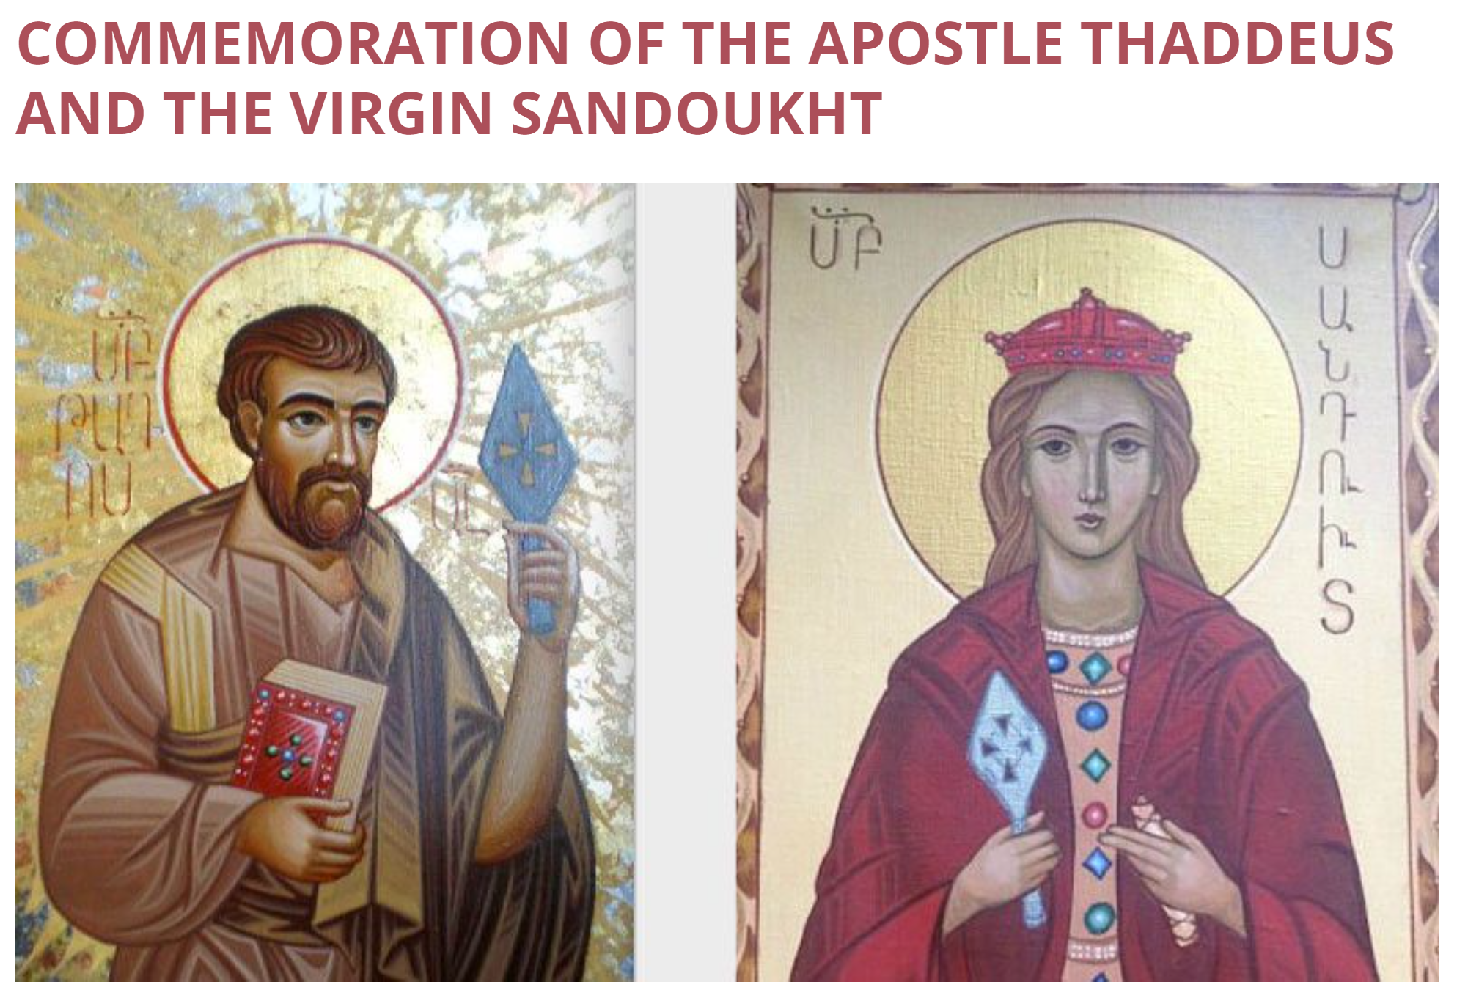
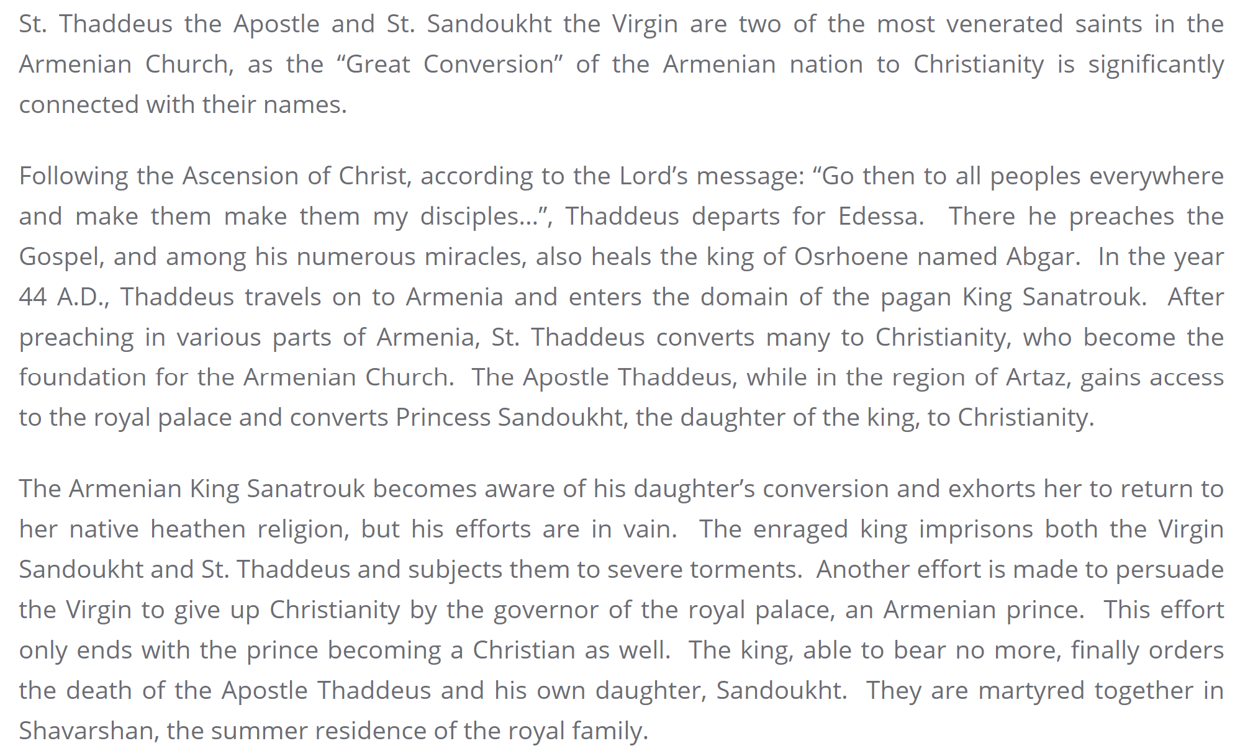
From the Website of the Diocese of the Armenian Apostolic Orthodox Holy Church in Georgia

