

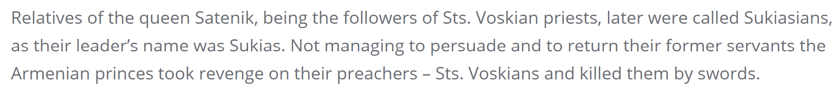

From the Diocese of the Armenian Apostolic Orthodox Holy Church in Georgia