
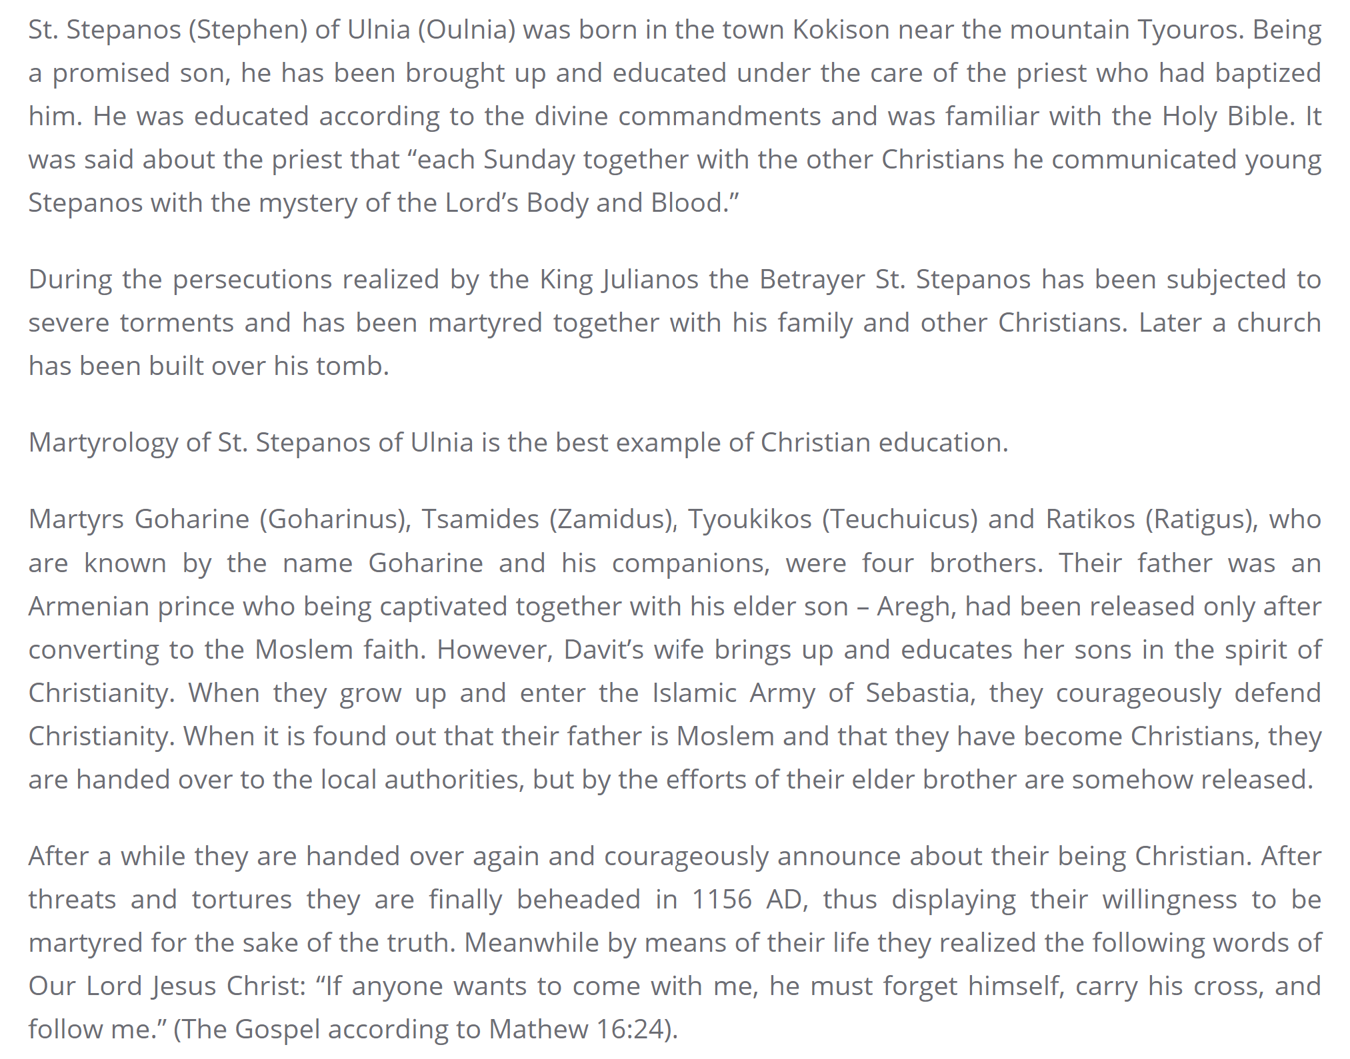
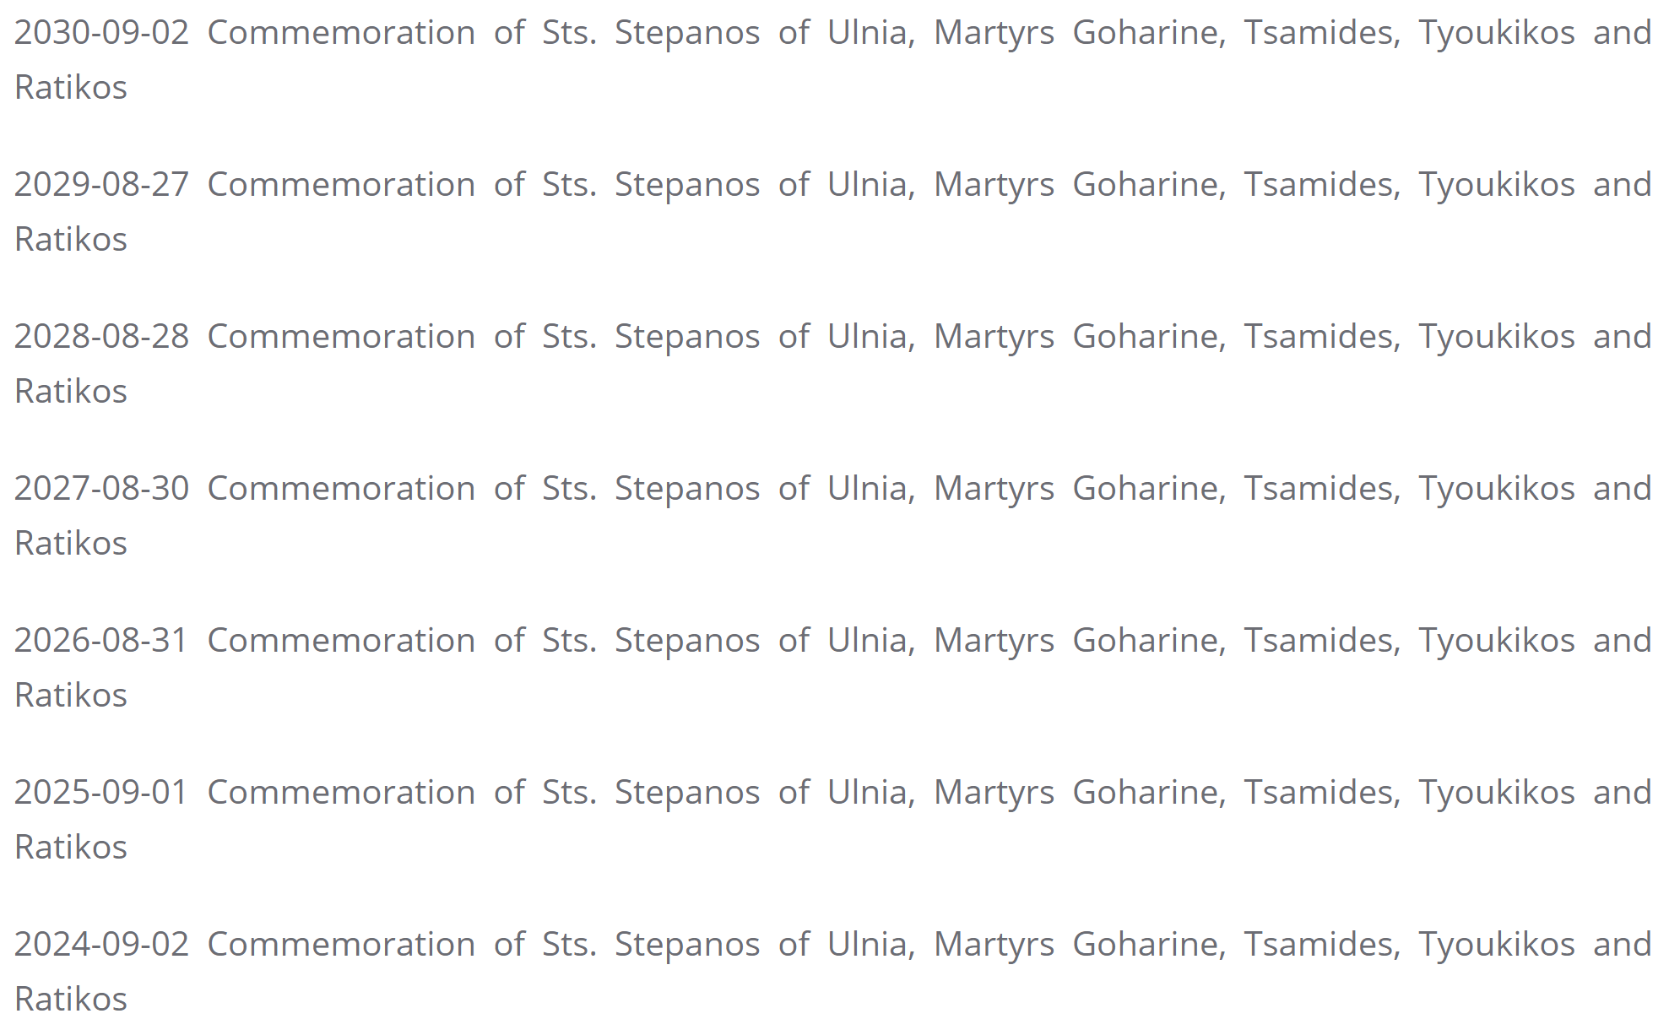

From the website of the Diocese of the Armenian Apostolic Orthodox Holy Church in Georgia

