ST SAHAK PARTHEV
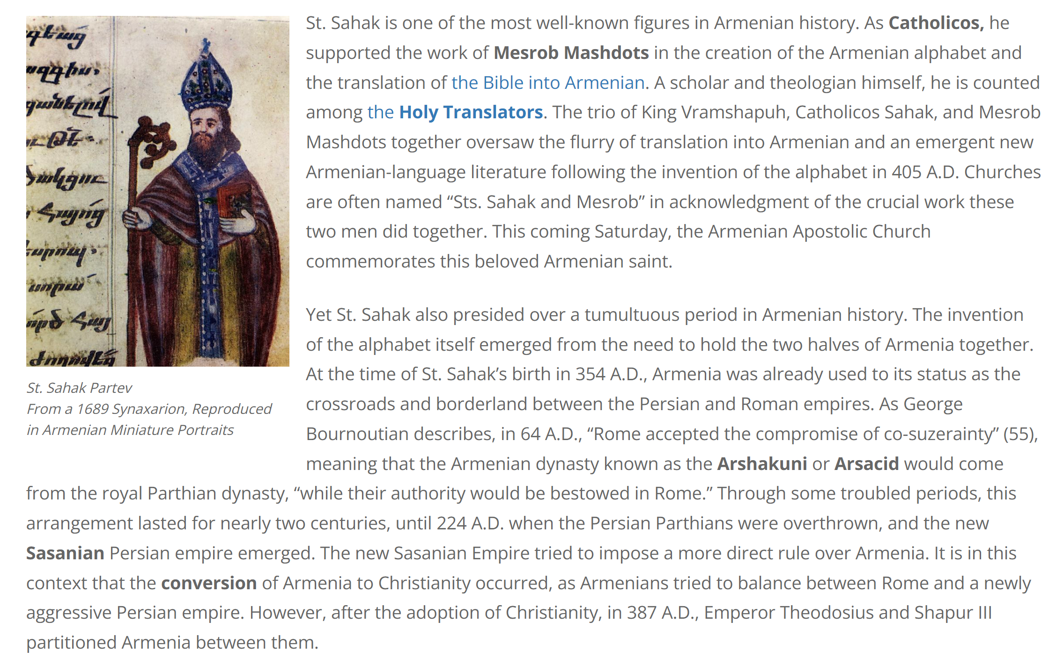
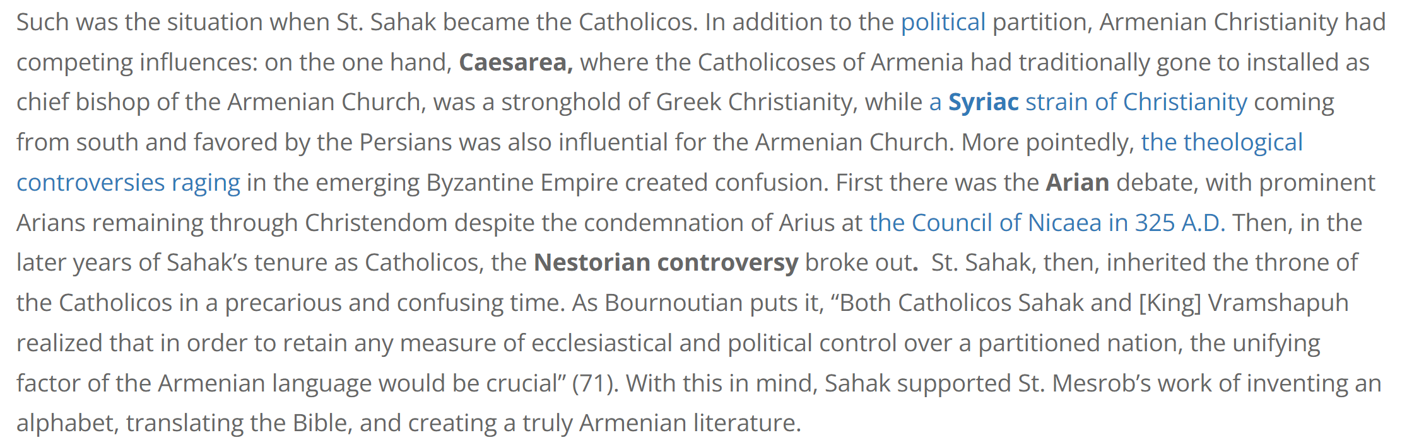

Vemkar.ED

