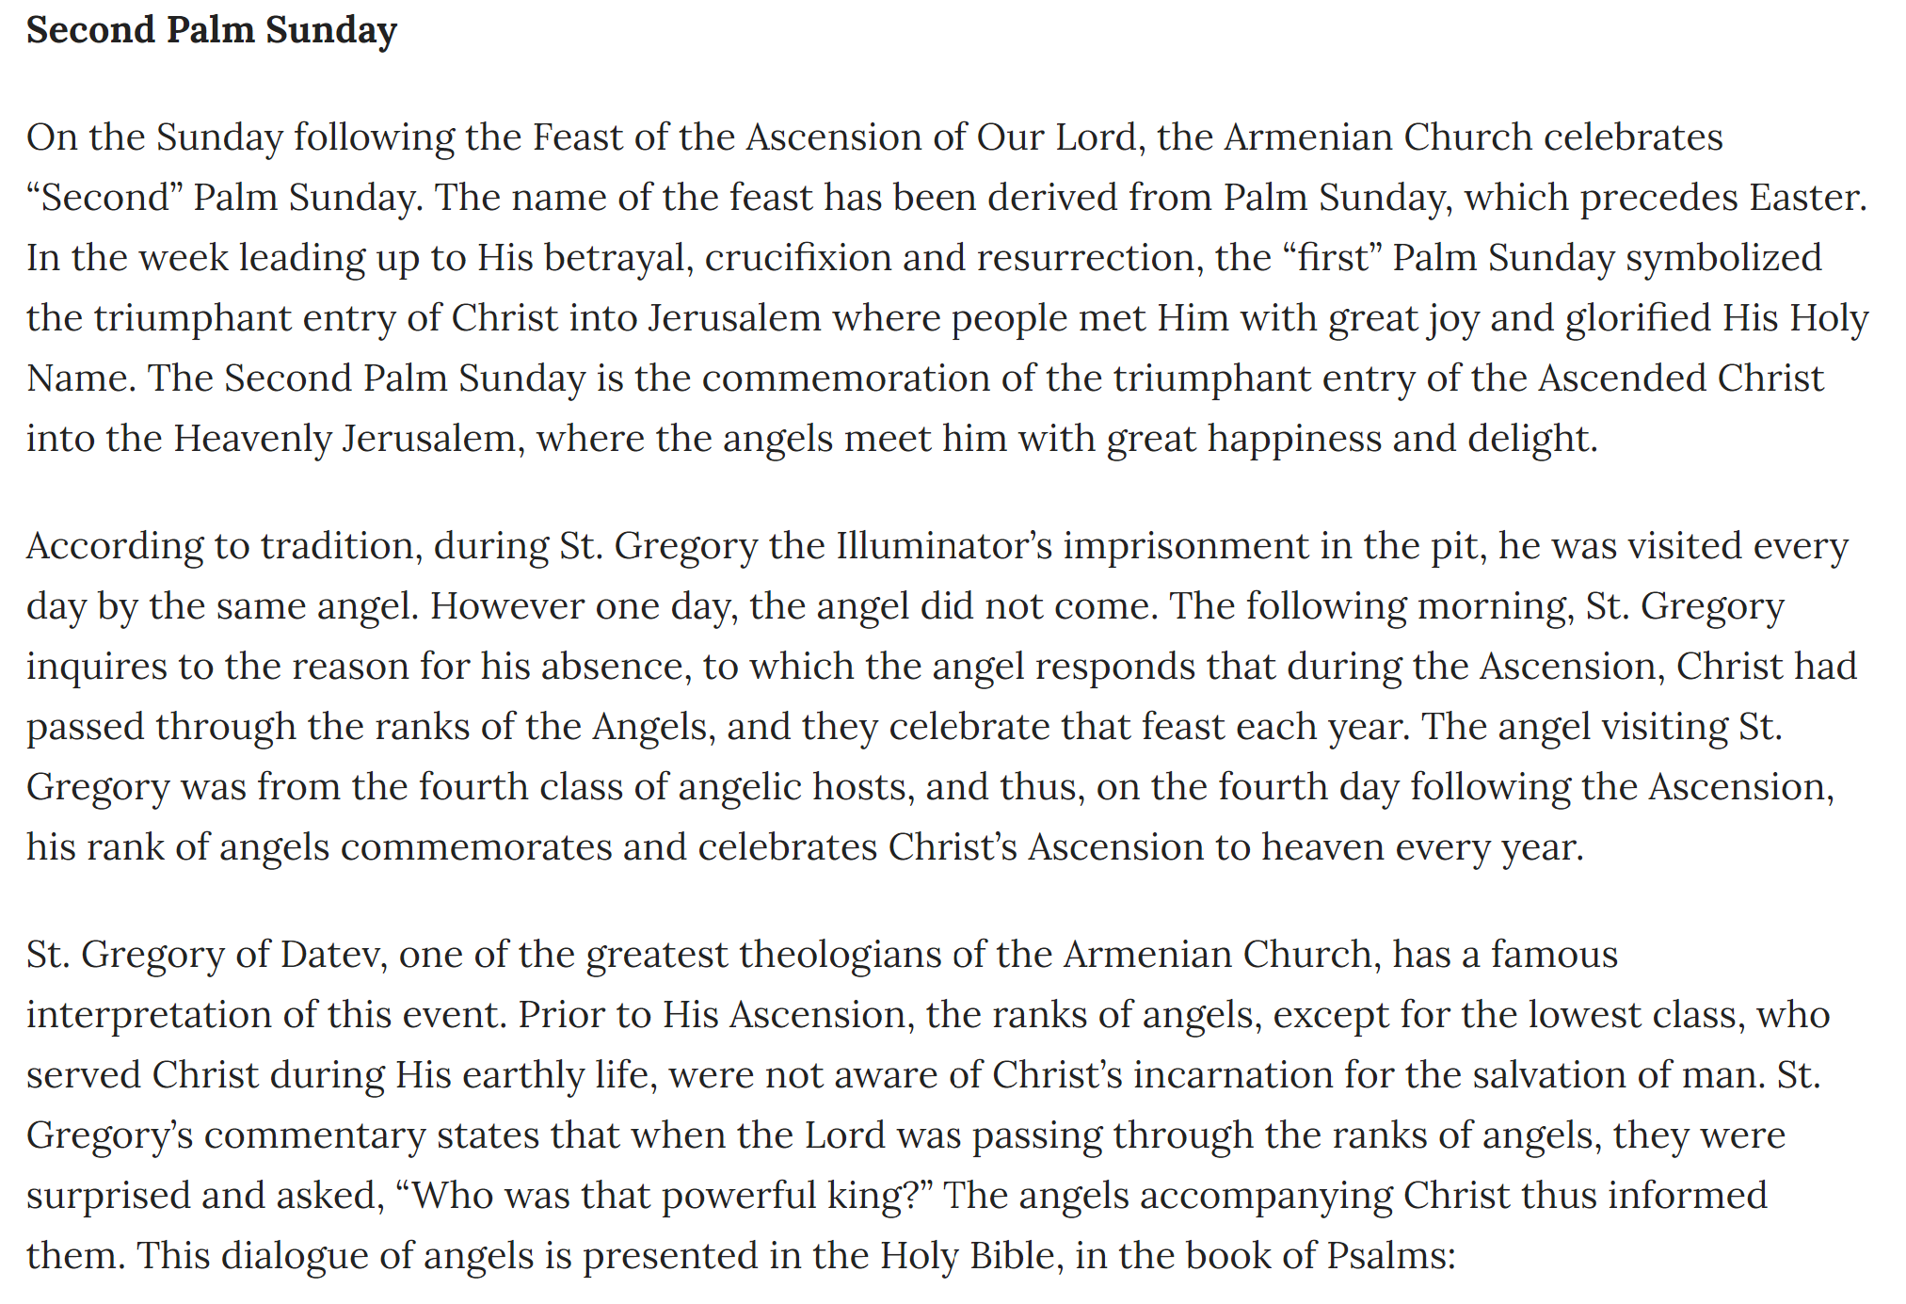

Taken from the ’Sunday Messenger’ May 8,2016
Holy Trinity Armenian Church, Cheltenham, PA

