**Sunday School Teachers’ Scripture and Feast Day Weekly Memo**

**Second Palm Sunday**

**From Today’s Readings**

**John 12:12-23** *Great crowds welcome Jesus into Jerusalem and wave palms and sing songs of praise. Although the disciples were present, it was only after Jesus rose from the dead that they truly understood the meaning of this day. Some Greeks ask the disciple Philip if they might be able to meet Jesus to which request Jesus responds affirmatively and that His hour had come, His final days were now before Him.* Discussion: Those who had heard of His miraculous raising of Lazarus were anxious to meet Jesus (vv 17-18). Which miracles of Jesus inspire you the most? Do they prompt you to draw closer to Him?

**Acts 23:12-35** *A group of Jews were conspiring to kill Paul while he was in Jerusalem. Overhearing their plot, Paul’s nephew reports it to the Roman commander who has Paul immediately transferred under heavy guard and with an explanatory letter to Felix, the Governor of Caesarea.* Discussion: Both St. Paul’s nephew and the Roman commander took risks in acting boldly against a popular movement. Has your faith every guided you to go “against the tide” even if it meant making an unpopular decision?

**1 John 5:13-21** *The writer assures the faithful of the truth of eternal life and that everything asked of God* according to His will *is heard and provided. Evil is real and everywhere; therefore God’s children need to remember all they have come to know about the Lord and keep themselves and one another from sin.* Discussion: Are you convinced that true life is found in Jesus (v.20)? What do you think “according to God’s will” means in v 14? (Perhaps that the more we pray and grow closer to God, the more we understand His ways and His will for us and therefore our requests spring from a faithful heart and not from a Christmas wish list.)

**Second Palm Sunday**

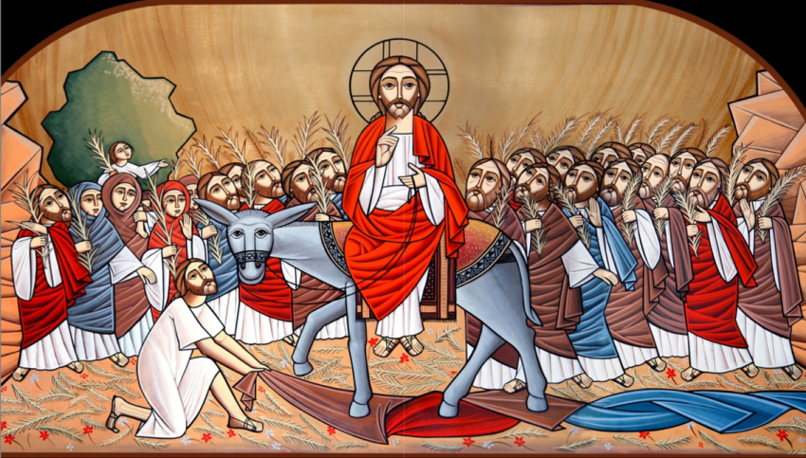Falling on the 4th day after Ascension, this Sunday is given its name based on the lection reading of the day, which is about Jesus’ entry into Jerusalem. Begining with New Sunday (directly after Easter), the Armenian church lectionary prescribes daily readings from the Gospel of John in sequential order arriving on this Sunday at the Palm Sunday story.

*This is a perfect time to reread and relive Jesus’ triumphant entry. Think of the people welcoming Jesus that day with palms and hosannas. Is your worship experience more like a hero’s victory or a funeral dirge?*

*Department of Christian Education*

*Diocese of the Armenian Church (Eastern)*

[*elisea@armeniandiocese.org*](mailto:elisea@armeniandiocese.org)