**Sunday School Teachers’ Scripture and Feast Day Weekly Memo**

**Red Sunday**

**From Today’s Readings**

**Acts 13:16-43** *St. Paul teaches in the synagogue in Antioch, reviewing the history of God’s intervention in the life of His people right up to Jesus’ resurrection. What God promised has been fulfilled, Paul exclaims, and through Jesus’ Resurrection, our sins are forgiven in a way that would have been impossible under the old Law.* Discussion: 1. St. Paul emphasizes that the salvation of God’s people is fully realized in the Risen Christ (vv. 38-39). Read more about this in Romans 3:20-24 and 8:3-4. 2. St Paul knew his Scripture and cited the history of his people as revealed in that Scripture. How would knowing the Old Testament help you understand your faith better?

**1 Peter 5:1-14** *Peter exhorts the church leaders to serve eagerly and to be alert because evil “prowls around like a roaring lion looking for someone to devour.” He stresses humility in all relationships; God opposes the proud and will honor the humble.* Discussion: 1. What two temptations for church leaders does Peter cite in vv. 2-3? (Greed, feeling superior to the flock)

2. What anxiety or concern would you want to turn over to the Lord? (v. 7)

**John 5:19-30** *Jesus replies to the Jews who criticize Him for calling God His Father and making Himself equal with God. He explains that He has been sent by the Father with whom He shares life and who entrusted Him alone to judge the world. Those who hear Jesus’ words and believe in the One who sent Him will have eternal life.* Discussion: “Whoever hears my word and believes Him who sent me,” says the Lord….”crosses over from death to life”: Powerful words that point to eternal life but also to the way we live *here and now*. In what specific ways do we cross over from death to life when we follow Jesus?

**Red Sunday**

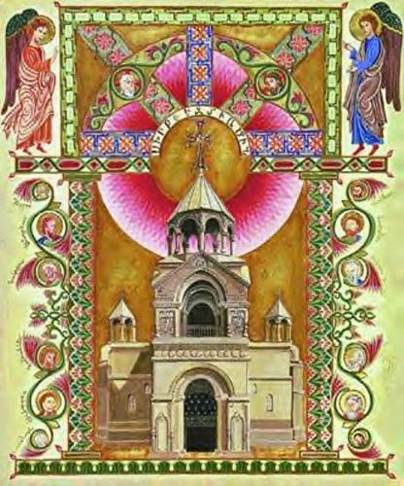The third Sunday after Easter (or the 4th of Eastertide, which includes Easter itself), Red Sunday has no ecclesiastical origin. It is not listed as such in the *Donatzouytz,* the Calendar of Feasts. Like last week’s Green Sunday (Sunday of the World Church), the day has been so named because of the colors of nature at this time of year: green for the new growth of spring, and red for the red flowers that were said to be in bloom.

*Department of Christian Education Diocese of the Armenian Church (Eastern)* [*elisea@armeniandiocese.org*](mailto:elisea@armeniandiocese.org)