**Scripture and Feast Day Notes**

**Poon Baregentan(Eve of Great Lent)**

**From Today’s Readings**

**Matthew 6:1-21** In His ‘sermon on the mount,’ Jesus teaches the virtueof humble, private acts of righteousness: giving without fanfare; praying privately, using humble words Jesus provides (the Lord’s prayer); being generous in forgiveness; fasting without anyone knowing; and treasuring what is eternal in value, not what will rot and rust. *Discuss/reflect:* *Jesus calls us to a higher morality, one that asks us to do the right thing not for public approbation, not to please people, but to please God. In what specific ways can doing this make for a better, happier life?*

**Romans 13:11-14:25** St. Paul urges his listeners to clothe themselves in Christ, living in ways that honor Him. And whatever holy disciplines they choose, whether it is setting aside a day as holy, fasting, or even *not* fasting, they should do so respecting others’ feelings and needs. “Let’s stop passing judgment on one another or putting obstacles in another’s way…” (14:13) *Discuss/reflect: Instead of judging, what should occupy our energy? Review 14:13, 17-18 and look ahead to 15:2 for answers.*

**Is 58:1-14** With a typical prophet’s passion, Isaiah shares God’s ire with a people who approach Him “as if they were a nation that does what is right…” (v.2) God demands an answer: Is fasting just a matter of sackcloth and ashes? Or is true piety about lifting up the oppressed, feeding the hungry and clothing the poor? *This* piety will touch God’s heart and then you will find “joy in the Lord…and He will cause you to ride in triumph on the heights of the land.” (58:14) *Discuss/reflect:* *What a ride that will be! Are you engaged in the god-pleasing acts of verses 6-7? If not, what can you begin to do so that your faith is more than ‘empty pious gestures?*

**Poon Paregentan! 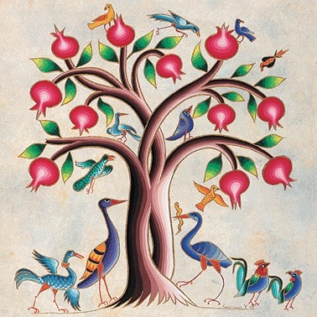Monday is the first day of Great Lent**

*Poon Paregentan* does not actually fall in Great Lent. However, it is traditionally counted as the first step on the Lenten journey. *Poon* means ‘real’ or ‘true.’ Since every fasting period begins with a festival day or *paregentan,* this one is marked as the ‘true’ one, the most important, since it precedes the greatest feast of the church, Easter. This ‘day of good living’ is often observed with festivities, dancing, and a carnival atmosphere to remind us all of the joy and vitality of Paradise and life itself. It also was the day to feast on and finish up all non-Lenten foods such as meat, dairy products, and fish. The *sharagan* (hymn) of the day sings of our earthly nature made glorious in the ‘garden of delight’ but also reminds us that even Adam and Eve had to exercise control and, sadly, failed to do so. Great Lent begins in the Armenian Church on Monday, the day after *Poon Paregentan*.

*Department of Christian Education*/ *Diocese of the Armenian Church of America/ (Eastern)/*[*elisea@armeniandiocese.org*](mailto:elisea@armeniandiocese.org)