**Sunday School Teachers’ Scripture and Feast Day Weekly Memo**

**Pentecost(Hokekaloost)**

**From Today’s Readings**

**Acts 2:1-21** While the disciples were gathered in prayer, the Holy Spirit came to them in a great wind and in the tongues of fire which appeared above each disciple, empowering them to speak different languages. Addressing the crowd’s rumor that the disciples seemed to be drunk, Peter recalled the prophetic words of Joel: the “Holy Spirit would be poured out over the people, gifting them with dreams and visions” and filling the world with a flurry of signs in anticipation of the coming of the Lord. *Discussion: What emotions drive the disciples in John 18:25-27 and 20:19? What could account for their changed behavior now?*

**John 14:25-31** In preceding verses we read about Jesus washing the disiples’ feet in the Upper Room where he predicts Judas’ betrayal and Peter’s heart-breaking denial. Here, He promises the Holy Spirit, the Counselor, whom the Father will send to remind them of all they had learned and continue to teach them. Leaving them with a peace that transcends the world’s understanding, He assures them that He will return. *Discussion: Does your faith in Jesus Christ provide you inner peace, no matter what shape your personal life or the world may be in? How might the Holy Spirit be reminding you of what Jesus taught?*

**Pentecost (*Hokekaloost)***

Falling 50 days after Easter, Pentecost celebrates the coming of the Holy Spirit upon the disciples, empowering them to go out into the world and share Jesus’ message of salvation. (See Acts 2:1-21 and above for full account.) Armenians are especially joyful at the gift of language received by the disciples Thaddeus and Bartholomew who were then able to journey to Armenia (each at a different time) to convert and baptize many. These First Enlighteners planted the seeds that St. Gregory would cultivate and bring to full bloom two centuries later when Armenia became the “first Christian nation” under his mentorship. This coming of the Holy Spirit took place at the time of the Feast of Weeks, a harvest feast of pilgrimage, so Jews from everywhere were gathered in Jerusalem to give thanks for the first fruits of nature. Similarly, Christian Pentecost is a festival of thanksgiving for the first fruits of the Holy Spirit.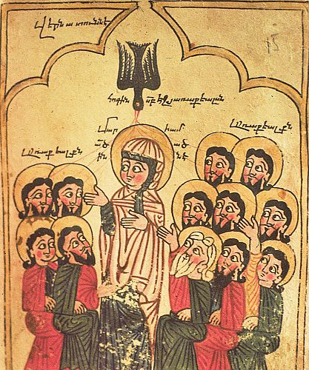 *The Holy Spirit descended on a group of Jesus’ followers whose hearts were open in prayer. How ready are you to receive the Spirit’s guidance and power in* your *life?*

*Department of Christian Education*

*Diocese of the Armenian Church (Eastern)*

[*elisea@armeniandiocese.org*](mailto:elisea@armeniandiocese.org)