**Scripture and Feast Day Notes**

**Paregentan of the Fast Transfiguration**

**From Today’s Readings**

**Isaiah 3: 1-11**  Isaiah continues to convey God’s displeasure with the prideful people of Judah and Jerusalem; He vows to remove His support and warns of disorder and even chaos because “their words and deeds are against the Lord, defying His glorious presence…” (v 8) *Discussion: Do the images of disrupted order in these verses bring to mind aspects of life today? What words and habits of your own might be said to defy God’s ‘glorious presence’?*

**Romans 11: 13-24**  St. Paul addresses the Gentiles whom he has helped bring to Christ, admitting that he had hoped to prompt envy in the Jews that they might also follow Jesus. Gentiles who count themselves among the faithful must remember that they have been grafted on to an ancient tree (Judaic roots) from which unbelievers have been trimmed. Rather than be arrogant, these new believers should realize that they can just as easily be cut from the tree because of unbelief. *Discussion: Paul warns believers against thinking they have a better, stronger faith than others. Do churches and individuals exhibit this judgmental behavior today?*

**Matthew 14:13-21** Hearing of John’s execution, Jesus withdraws in solitude but becomes immediately compassionate towards the crowds that follow Him. He heals the sick and when the disciples tell Him it is late and they must be sent away to find food, He exhorts them to feed the crowd themselves. With just two fish and five loaves of bread, Jesus feeds more than 5,000, giving thanks and breaking the bread in a moment that foreshadows the Last Supper. The 12 baskets of leftovers point to the banquet of the Messiah in the final coming of the Kingdom. *Discussion: Have you ever felt that with the help of God your personal resources have been stretched beyond what you could imagine?*

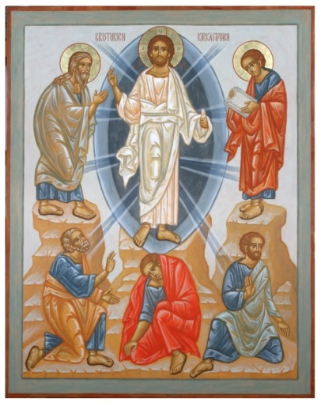 **Paregentan of the Fast of Transfiguration**

The church prepares to celebrate one of the five major feasts next Sunday, July 8, with a week of fasting preceded by a “paregentan” or day of celebration (lit: ‘good-living’). Fasting before a major feast is a lost practice for most Christians. How unfortunate since this signifies that the feast itself has lost both its historic and timeless impact on our lives! With prayer and other spiritual disciplines, fasting is a way of getting the entire body and soul ready for an important church event. Paregentan days precede fasts throughout the church year; the greatest season of fasting – Great Lent – is launched by the greatest Paregentan: “Poon Paregentan.” *Reflection: How can I spend the coming week preparing to celebrate my Lord’s transfiguration on Mt. Tabor, at which time He was made radiant in the presence of his closest disciples, Peter, James, and John, flanked by Moses the Lawgiver and Elijah the Prophet, and affirmed again by the Father and the Holy Spirit?*

*Department of Christian Education*

*Diocese of the Armenian Church (Eastern)*

[*elisea@armeniandiocese.org*](mailto:elisea@armeniandiocese.org)