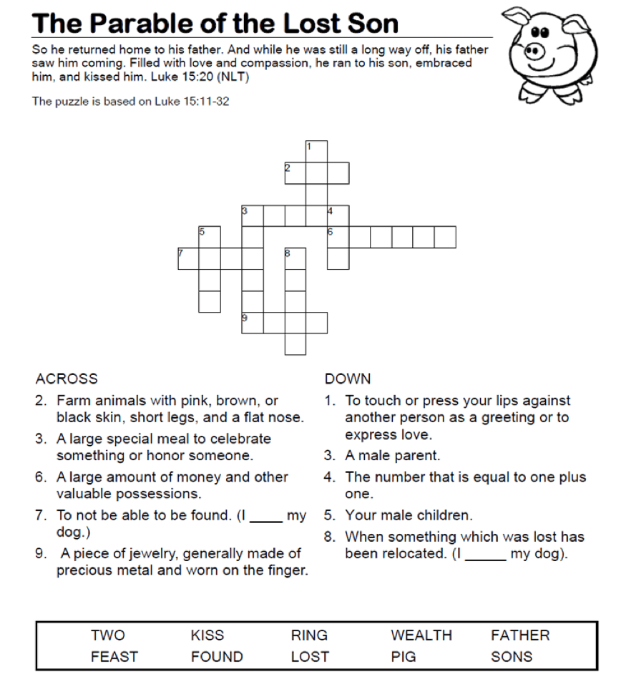

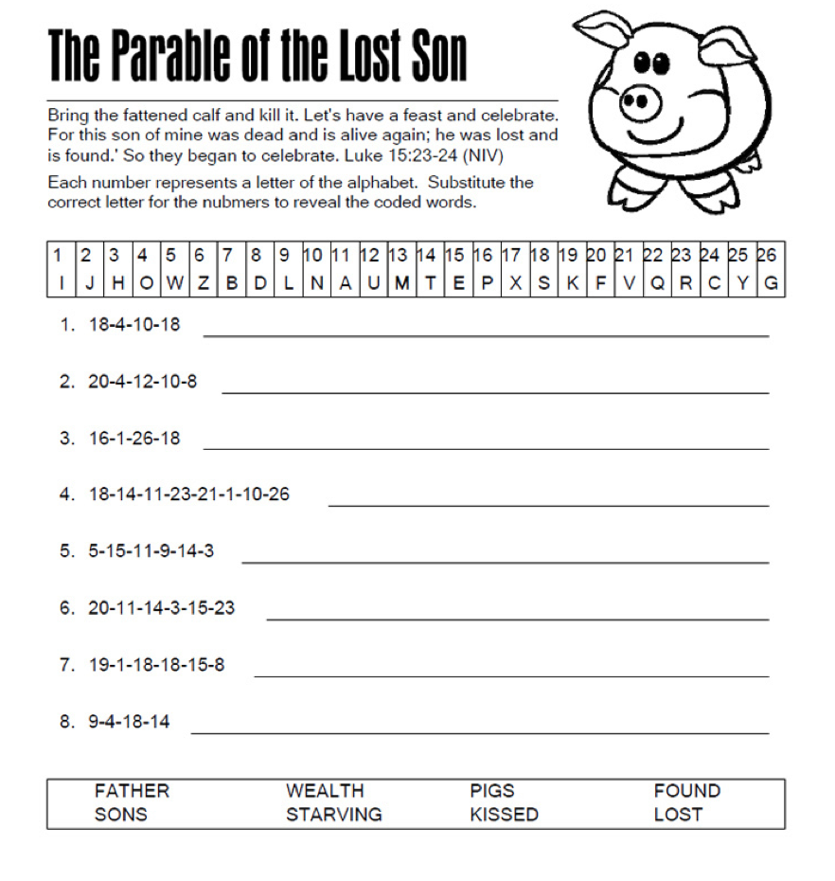

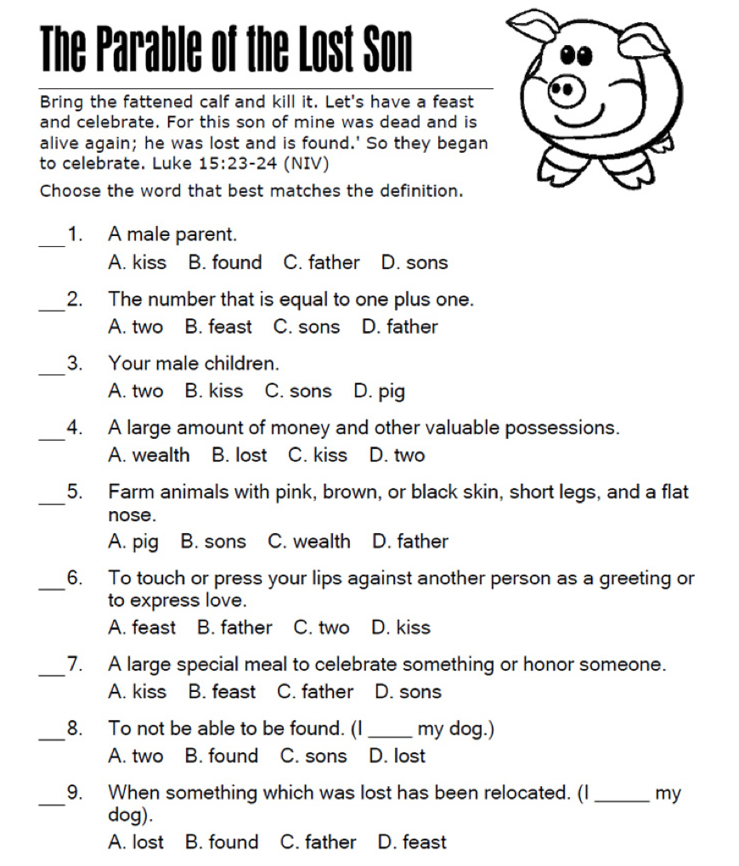

**ANSWER KEY:**

**Crossword:**

ACROSS DOWN

2. Pig 1. Kiss

3. Feast 3. Father

6. Wealth 4. Two

7. Lost 5 Sons

9. Ring 8. Found

**Decoder:**

1. Sons
2. Found
3. Pigs
4. Starving
5. Wealth
6. Father
7. Kissed
8. Lost

**Multiple Choice Quiz**

1. C
2. A
3. C
4. A
5. A
6. D
7. B
8. D
9. B