**Sunday School Teachers’ Scripture and Feast Day Weekly Memo**

**Palm Sunday**

**From Today’s Readings**

**Matthew 20:29-21:17** *The healing of the two blind men is a poignant prelude to the story of Jesus’ triumphal arrival in Jerusalem (see below). The two persist in loudly declaring their faith despite the crowd’s rebuke. Upon being healed by their Lord, they followed Him. The passage continues with the Palm Sunday story (21:1-11) and the account of Jesus driving the moneychangers from the Temple.* Discussion: If Jesus said to you (as He did to the blind men) “what do you want me to do for you?” how would you answer?

**Philippians 4: 4-7** *What a joyful series of declarations: rejoice in the Lord, know that He is near, be gentle with everyone, don’t worry about a thing, pray your gratitude, and God’s peace will guard your heart in Christ Jesus!* Discussion: What do *you* worry about (v. 6)? What would St. Paul suggest to help you? (*Turn to God, pray, let His presence comfort and strengthen you-- P.S. It’s a known fact that gratitude pushes out fear and anger…)*

**Zechariah 9: 9-15** *Set in the context of the Jews’ return from the Babylonian exile and the rebuilding of Jerusalem, Zechariah looks expectantly to the Lord’s return. In these verses, we see a striking prophecy of Jesus’ entry into Jerusalem “gentle and riding on a donkey.”* Discussion: Why does Zion’s King enter Jerusalem on a donkey (v 9) and not a war horse

(v 10)? (*As opposed to the prideful entry of warlike kings, this set an example of humility, forbearance, and meekness; His peaceful kingdom was not of this world. See Hosea 1:7 and Micah 5:10 for the Lord’s promise to be victorious with*out war and horsemen*.)*

**Palm Sunday (***Dzaghgazart)*

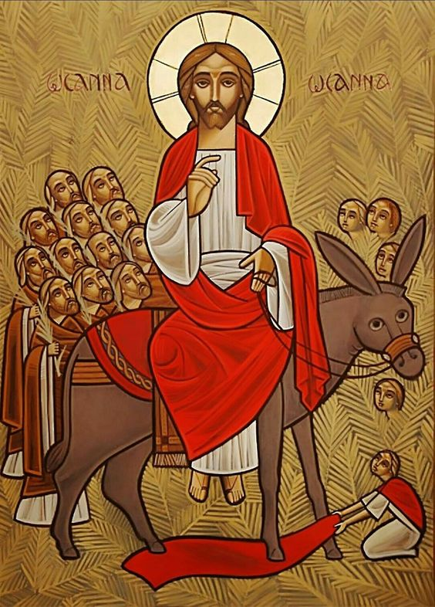This day recalls Jesus’entry into Jerusalem. He is greeted by throngs of people laying their cloaks and palm branches on the road before Him as a royal carpet of welcome. Matthew understood the event as the fulfillment of specific prophecies, including Zechariah 9:9 (today’s reading). Therefore, for many gathered, this *was* the entrance of the Messiah and conformed fully to Old Testament prophecy and Jewish expectations. Yet how poorly the crowd understood the nature of the kingdom and the king they were welcoming, since not long afterwards their “Hosannas!” turned to the jeering shouts of “Crucify Him!” The service of the *Opening of the Doors* is also held on Palm Sunday, during which the priest and people pray for entry once again into God’s presence. The term *Dzaghgazart,* (“adorned with flowers”) may refer to an older pagan feast.

*Department of Christian Education*

*Diocese of the Armenian Church (Eastern)*

[*elisea@armeniandiocese.org*](mailto:elisea@armeniandiocese.org%0d%20%20ericv@armeniandiocese.org)