No one Knows the Hour: Jesus’ Second Coming:

Mathew 24:36-42 (NRSV)

**ADVENT SUNDAY CLOCK**

The Bible says that no one knows the day that Jesus is coming back! This little clock is great for any age. It really doesn’t matter if the kids put the number in the correct order or not because we don’t know the time!

But about that day and hour no one knows.

(Matthew 24:36)

[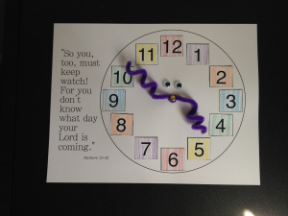](https://biblecraftsforyourkiddos.files.wordpress.com/2015/04/photo-copy-72.jpg)

*.*

**MATERIALS:**

* Paper plate
* Brass tab ("brass brad")
* Scissors
* Pencils or markers
* Glue sticks
* Googly eyes
* Pipe cleaner “hands”
* Numbers
* Sharp pencil or nail
* *Optional*: Number Template *(to follow)*

**DIRECTIONS:**

* Poke a hole in the center of the plate with a nail or sharp pencil (adult assistance)
* Give children a paper plate and have them glue or draw numbers around it, like a clock.
* On the face or back of the clock, have students copy:

*But about that day and hour no one knows (Matthew 24:36)*

* Give each child a brad and poke the brad into the center of the clock face and secure it.
* Wrap a pipe cleaner around the brad and have the children bend and point the “hands” any way they like.
* Glue on the googly eyes to complete the clock face.

