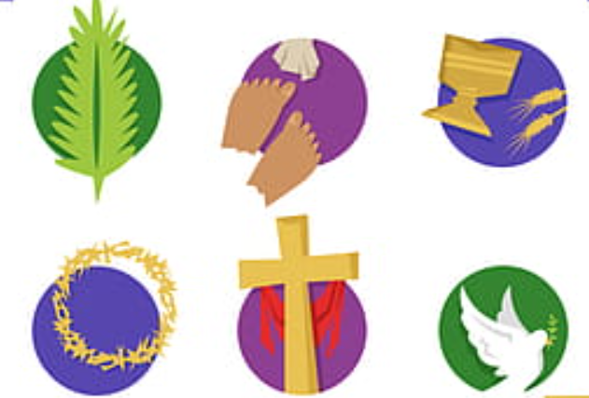

JOURNEY THROUGH HOLY WEEK

Prepared by the

Christian Education Council

Western Diocese - Armenian Church

2011