**Sunday School Teachers’ Scripture and Feast Day Weekly Memo**

**Green Sunday**

**From Today’s Readings**

**John 2:23-3:12** *Nicodemus was a Jewish leader and teacher who was impressed with the “signs and wonders” Jesus performed and wanted to know more. Jesus tells him of a second, even more life-changing birth when we are born again “of water and the Spirit.”* Discussion: The Armenian Church baptizes infants as godparents, parents, and community stand witness and pledge to nurture the child’s faith. We are “born again” at baptism, but what are ways to continue this spiritual birthing throughout our lives?

**Acts 9:23-31** *The newly converted Saul (St. Paul) was preaching the good news of Jesus Christ in the synagogues of Damascus. When his life was threatened, followers lowered him over a wall in a basket. Barnabus introduced and defended him to the apostles in Jerusalem who were understandably fearful (Saul was a former persecutor of Christians). The church experienced peace and great growth.* Discussion: The church is described as “living in the fear of God.” (v.31) The Greek word “phobos” denotes the reverential awe of those “struck by the holiness of God.” Perhaps this simply means that these early faithful were living reverent lives. How seriously do *you* take God’s authority and holiness? What are some specific signs of this?

**1 Peter 2:1-10** *The apostle Peter described all believers as “living stones” who come to the Living Stone, Christ, to be built into the spiritual house that is the Church.* Discussion: Jesus as the cornerstone of our lives – a beautiful image! Why do you think people “stumble” over this stone (v. 8)? (*doubting Jesus’ authority over our lives; or perhaps we don’t want to give up the worldly things we value, not yet understanding they are worthless compared with knowing Christ – see Philippians 3:8)*

**World Church (Green Sunday)**

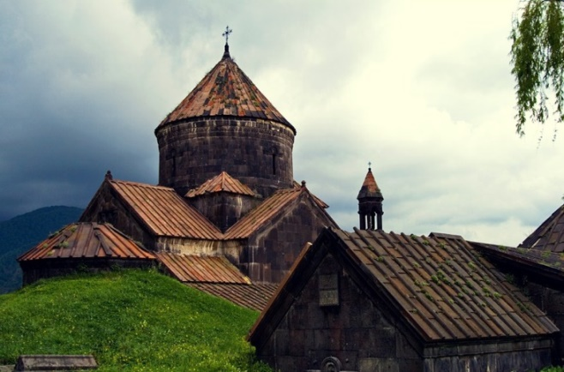The second Sunday after Easter is dedicated to the very first church in the world – established in Jerusalem by Christ. It was there in the Upper Room (*Ver-na-doon*) that Jesus shared His Body and Blood in the bread and wine of the new Covenant with his disciples and where they in turn gathered with other followers before and after the Resurrection and at Pentecost. It was this nucleus of Christ’s church that would one day become a church of millions. Although the site remains a place of pilgrimage, the original building itself no longer exists. In its place, we have a *world* church—the entire earth which the Christian Church has taken under its roof. The name “green” conveys the idea of new life in Christ’s resurrection as well as its glorious evidence in nature at this time of year.

*Department of Christian Education*

*Diocese of the Armenian Church (Eastern)*

[*elisea@armeniandiocese.org*](mailto:elisea@armeniandiocese.org)