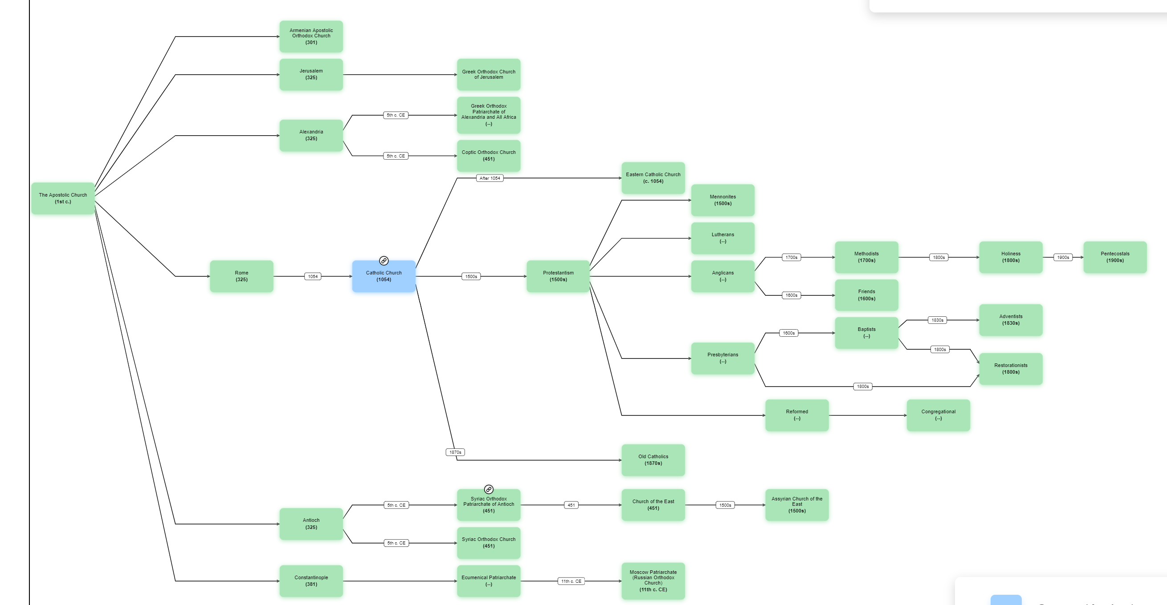
ARDA - Association of Religion Data Archives

