**Scripture and Feast Day Notes**

**Fourth Sunday after Transfiguration**

**From Today’s Readings**

**Isaiah 58:13-59:7** These verses address the attitudes of the Jewish community upon their return from exile. Following in a long tradition of prophetic criticism, the writer exhorts people to honor God’s holy day with joy and hearts of faith. Worship is meaningless if it is offered up by a sinful, unjust society. *Discussion: Think of how* you *honor the Sabbath and the promise of great joy when you put God front and center. Do you seek “your own interests” (58:13), rather than God’s command to love Him and one another? Is there a way you can change Sundays for you and your family that might be more God-pleasing and lead to deeper happiness for you all?*

**1 Timothy 4:12-5:10**Placed in charge of the church founded in Ephesus by St. Paul, Timothy is encouraged to be confident in his gifts, even though he is a young man. Be an example in all you do and say, he is reminded, and treat others with love and respect, always helping those in need. *Discussion: We’ve all heard the expression “he talks the talk but doesn’t walk the walk.” Why is personal example so important in our faith (v.12)?*

**John 3:13-21** Jesus is teaching the Pharisee Nicodemus and has just given his famous explanation of being born again. He now concludes with the equally renowned words that “God so loved the world, He gave His only begotten Son.” (3:16) Through the Son the world is saved, and through His light and truth, people are redeemed. Sadly, many prefer the darkness (19-20). *Discussion: To live in truth and receive Christ’s promise of new life, what might you need to do?*

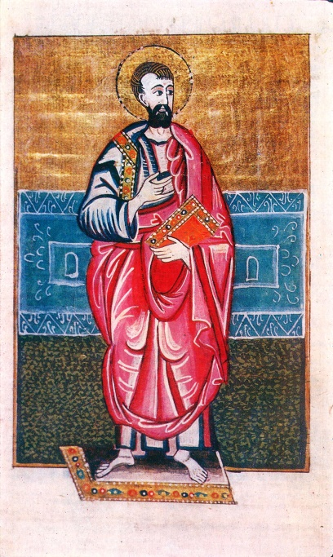**Feast of St. Vahan of Goghtn (703-737 AD)**

St. Vahan’s story is one of exile and thwarted happiness rooted in enduring faith. His father, Prince Khosrov, had been martyred in 707 during the Arab persecutions and so at the tender age of four Vahan was taken to Damascus and brought up in the royal court. A favorite, he was eventually made chancellor to the Amirabed (king). In 719, St. John of Otzoon visited the city and convinced the emir Omar to allow captured Armenians to repatriate. As the emir valued Vahan’s service highly, he allowed him to return to Armenia under the proviso that he come back in a year. Once home, Vahan married an Armenian princess, and when he heard that the emir had died, decided to remain in Armenia, living a peaceful, happy life for ten years. When Omar’s successor sought his return, Vahan abandoned his family for their safety, wandering for a time and eventually becoming a monk. Finally, after years of exile, he went to Damascus to seek mercy and freedom. But the emir refused and offered him an even more eminent position which Vahan spurned, leading to his imprisonment and martyrdom.

*Department of Christian Education*

*Diocese of the Armenian Church of America (Eastern)*[*/elisea@armeniandiocese.org*](mailto:/elisea@armeniandiocese.org)