**Scripture and Feast Day Memo**

**Fourth Sunday After Pentecost**

**From Today’s Readings**

**Isaiah 1: 21-31** The prophet continues God’s message of judgment leading to redemption. Here a once-faithful Jerusalem is depicted as an adulteress; justice is not served, rulers seek bribes, and widows are neglected. But God will purge them of their impurities and through merciless judgment will restore the city to righteousness. *Discussion: Does your church seek justice for the oppressed in your community? What situations ought it to address?*

**Romans 7:25-8:11** This chapter -- in which the word “spirit” appears 29 (!) times -- answers the question: who can free me? Gratefully*,* Paul declares that because God offered up his own Son as a sin offering, we have been set free from the law of sin and death, something the old Law could not have done alone. Those not living according to the Spirit, controlled by a sinful nature, are hostile to God and would not even know how to please Him. *Discussion: St. Paul says that those who “live their lives according to the Spirit, have their minds set on what the Spirit desires.” What are some practical changes you can make in your life so that you might live according to the Spirit and grow closer to God’s way of seeing things?*

**Matthew 12: 38-45** Despite all the miracles that Jesus has already worked, the scribes and Pharisees ask for more signs. The exasperated Jesus cites Jonah, first for how his message of repentance was heeded by the Ninevites (non-Jews) and also for the significant symbol of Jonah’s ‘burial’ in the belly of the fish for 3 days and 3 nights. Evil is alive and well in a generation that does not understand Jesus’ authority. *Discussion: Jesus gives examples of non-Jews (the Ninevites, the Queens of Sheba) who heed God’s commands. How does being neglectful of God’s presence allow evil to take hold? Have you felt this happen in your own life?*

**Sts. Drtad the King and Queen Ashkhen**

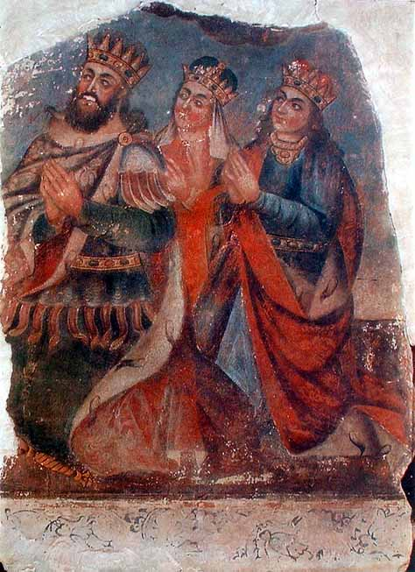This royal couple played a key role in Armenia’s conversion to Christianity. St. Gregory the Illuminator’s father, Anak, had assassinated Drtad’s father, Khosrov II. Years later, the Illuminator was proselytizing in Armenia and eventually imprisoned by Drtad. Because of this and Drtad’s execution of Gayane, Hrispime and their fellow nuns, the King was said to have lost his sanity. His Queen and his sister Khosrovitookht had both been converted and were secretly supportive of the Christian movement (his sister was thought to be the one who kept St. Gregory alive during his 13 years in the pit). Upon Drtad’s miraculous healing by St. Gregory, the King and Queen, the royal family, and the army were converted. Drtad and Ashkhen encouraged the preaching of the Good News throughout Armenia and even assisted physically with the building of Holy Etchmiadzin. At the end of their lives, they withdrew to separate retreats, dedicating themselves to the Lord.

*Department of Christian Education*

*Diocese of the Armenian Church (Eastern)*

*elisea@armeniandiocese.org*