**Scripture and Feast Day Notes**

**Fifth Sunday After Pentecost**

**From Today’s Readings**

**Isaiah 2:5-11** Isaiah continues to unfold God’s warning that the people of Judah have abandoned Him for superstition and idols. Their treasure is no longer their Lord, but gold and silver, horses and chariots. But God’s majesty will bring down the arrogant. In the last days, “the Lord alone will be exalted.” (v.11) *Discussion: In the tension between serving God and serving money and “stuff,” which seems to be winning in your life right now? Why?*

**Romans 8:31-10:4** St. Paul outlines the power and mystery of God’s sovereignty. His invitation might be to all the “offspring of Abraham,” but only those who respond to God’s true heart can enter into this relationship with Him; then neither persecution, nor famine, nor any danger, in fact nothing, “in all creation will be able to separate us from the love of God which is in Christ Jesus.” (8:39) Paul expresses compassion for the Israelites who still believe the Law is the way to God rather than faith in His love and mercy. *Discussion: How can zeal for God, even zealous “busyness” in serving the church, sometimes get in the way of knowing Him?(10:2)*

**Matthew 13:24-30**  In the Parable of the Weeds, Jesus uses the harvest as a common symbol for the final judgment, advising believers to be tolerant and patient. The “weeds” – the evil and the unjust – are brought into being by Evil itself and will prosper side by side in God’s creation. Only in the fullness and end of time, will Christ’s angels pull out and burn the weeds. The righteous will shine like the sun in the Father’s Kingdom. Jesus explains the parable to His disciples in vv 36-43. *Discussion: Does it trouble you that bad people prosper and good people suffer on earth? What does God call us to do, nevertheless, regarding this temporary injustice? How are you carrying this out in* your *life?*

**Feast of the 12 Apostles and St. Paul**

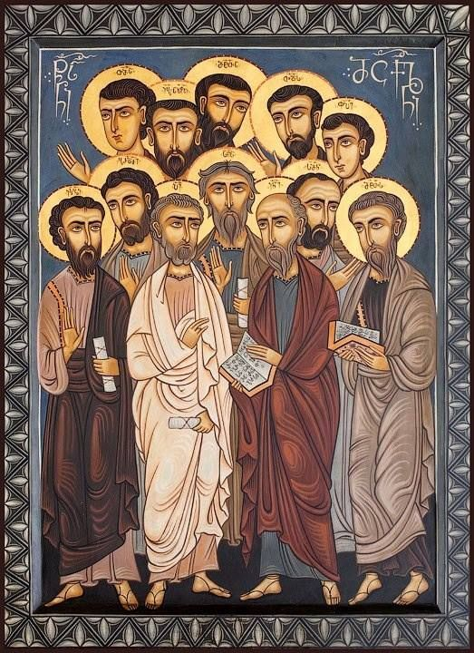Apostle is a Greek word meaning “one who is sent forth” having been entrusted with a special mission. So it was that Jesus called 12 men to be with Him, learn from Him, and ultimately bring the world to Him. In Matthew 4:19, Jesus gave the fishermen Peter, Andrew, James and John a simple invitation: “Come, follow me, and I will make you fishers of men.” In this way he asked them to leave where they were (their fishing boats and business), journey with Him daily, open their hearts to being changed by God, and call others to the same journey. Many other men and women followed Him as well. In the same spirit, the disciples (Acts 1:21-22) chose Matthias to replace Judas because he had “journeyed with Jesus daily and was ready to witness to Him.” St. Paul, in turn, became the great apostle to the Gentiles, widening the Christian world even further. *Reflection: How do* you *measure up to Jesus’ call to leave where you are (mentalities, prejudices, priorities), follow Him* daily, *and then share the Good News with others?*

*Department of Christian Education /Diocese of the Armenian Church (Eastern)*

[*elisea@armeniandiocese.org*](mailto:elisea@armeniandiocese.org)