**Scripture and Feast Day Notes**

**Fifth Sunday After the Transfiguration**

**From Today’s Readings**

**Isaiah 7: 1-9** Syria (Aram) and northern Israel (Ephraim) were poised to attack Judah over a disagreement concerning their enemy Assyria. The hearts of the people of Judah were filled with fear (v.2). God instructs Isaiah to tell their king Ahaz to have courage and be firm in his faith for “Unless your faith is firm, *you* shall not be firm!” (v. 9) *Discussion: What situation are you facing that frightens you now? What makes it difficult for you to trust God for strength and guidance?*

**1 Corinthians 13:11-14:5** Previously, St. Paul had outlined the need for us to discern our spiritual gifts so that we might serve the common good and that without love none of these gifts are effective. Here he reminds us that we are like children until we mature spiritually: only then will we see that love outlasts even those things that endure forever such as faith and hope. In praising prophecy over the gift of tongues, he praises that gift which serves others rather than one’s self. *Discussion: In what ways do you think you talk, think, and reason like a child (v.11) when it comes to God?*

**Mark 2:1-12** In this beautiful story of the healing of a paralytic, four friends of a paralyzed man, unable to get through the crowds in a home where Jesus is teaching, lower him from a hole in the roof so that he might be healed. By first forgiving the man’s sins, Jesus is boldly declaring His divinity since God alone can forgive sin; such forgiveness better reveals His identity as the Son of God than do the miracles He performs. This spiritual healing is immediately followed by a physical cure: the man rises up and walks. *Discussion: Even as we ask for all sorts of physical benefits in our prayers, perhaps God’s greatest gift is the restoring of souls to health. In what ways, for example, is sin like paralysis? How might we be made free through forgiveness?*

**Feast of Shoghagat**

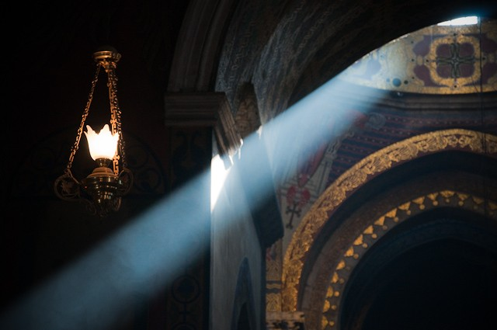*Shoghagat* might best be translated in a phrase: “rays of light came down as droplets from heaven.” The term and the Feast Day derive from St. Gregory’s vision as recorded in the 5th century history by Agathangelos. In that account, we read how King Drtad and the nobles fasted and repented, listening attentively to St. Gregory’s every word as he taught them the long history of God’s plan of salvation for humankind. He shared a momentous vision he had seen: of light flowing to the earth, of Jesus striking the ground with a golden hammer, angels, thunderous sounds as the firmaments opened and springs gushed forth, columns of cloud and fire. It was on that site that he understood he was to build a Cathedral (Etchmiadzin, lit. “where the Only-Begotten descended) and chapels to Sts. Hripsime, Gayane, and their sister nuns. Since the Mother Cathedral is dedicated to St. Mary, the feast is always observed on the Saturday preceding the Assumption.

*Department of Christian Education*

*Diocese of the Armenian Church of America (Eastern)*[*/elisea@armeniandiocese.org*](mailto:/elisea@armeniandiocese.org)