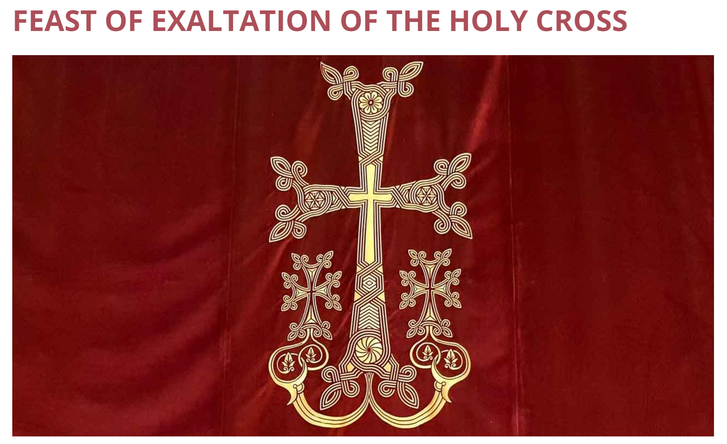
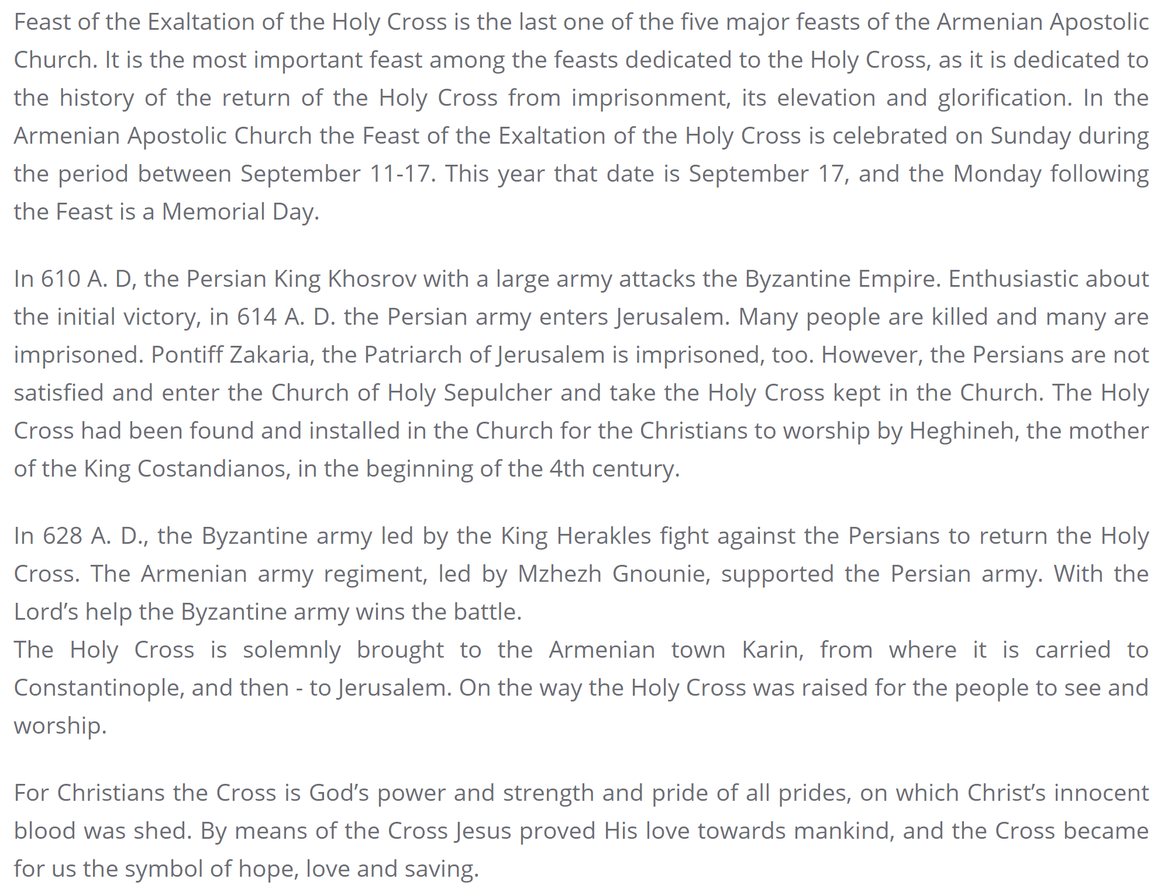
9-15-2024, 9-14-2025, 9-13-2026, 9-12-2027, 9-17-2028, 9-16-2029, 9-15-2030
From the website of the Diocese of the Armenian Apostolic Orthodox Holy Church of Georgia

