**Scripture and Feast Day Notes**

**Exaltation of the Holy Cross**

**From Today’s Readings**

**John 3:13-21** The Pharisee Nicodemus has privately sought Jesus to learn more and just heard what it means to be born again in the Holy Spirit, into a new life. Here Jesus tells him that God the Father sent His Son into the world not to condemn it but to save it, so that all who believe in Him might have eternal life. Light has prevailed over darkness and all are invited to live in that light for God’s glory. *Discuss/reflect: Imagine that who you are is like a dark room and God’s bright light reveals all its hidden places. What would it disclose?*

**Galatians 6:14-18** St. Paul declares that the cross is the only source of pride and joy to him and that in Christ the world has been crucified to him.His past, his “tribe,” his earthly affiliations mean nothing – he has been made new in Christ (v.15). *Discuss/reflect: Prayerfully read verse 14 as if* you *were making this declaration. Read and re-read. Is it as true for you as it was for St. Paul? If not, describe what it would mean in your life if it were.*

**Isaiah 49:13-23** A refrain of joyous comfort from God who declares that His people will never be forgotten. “Lift up your eyes and look around” the Lord declares (v.18). Even if they feel forsaken, in ruin, God reminds them that His love is more powerful than that of a mother for her child. The analogy of a mother’s love in verse 15 is another example of God’s tenderness expressed in female imagery *Discuss/reflect: Why is it hard to remember God’s love and blessings in the midst of difficulty? What might it take for you to “shout for joy”?*

**Today is the Feast of the Exaltation of the Holy Cross**

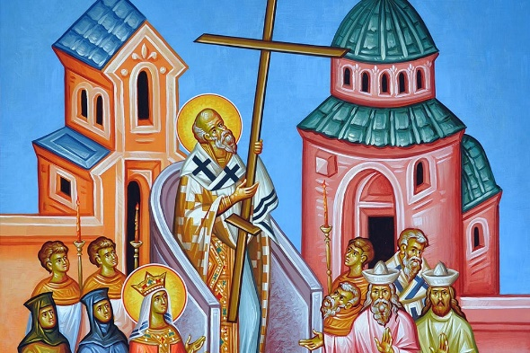The Exaltation of the Holy Cross is one of the five major feasts (*daghavars)* of the Armenian Church, observed on the Sunday nearest September 14. On that day, there is a procession and an antasdan service, which is the blessing of the fields, popularly known as the four corners of the world.

In early times, the most important church in Jerusalem was named the Church of the Holy Cross. It had been built over the place where Jesus was crucified. Every year, the bishop would take out a relic of the cross and elevate it over his head for the people to honor and venerate. This ceremony is the origin of the Feast of the Exaltation of the Cross.

Traditionally, we connect another story to this Feast Day. In the 7th century, the Persians captured the cross of our Lord after devastating the city of Jerusalem. Emperor Heracles fought a battle against them (in which Armenian troops participated) and liberated the cross. Upon his return, he exalted it in Christian lands, including Armenia, through which the victorious army carried it back to Jerusalem. *Activity: On this feast day, put a small cross in your pocket and reflect reverently throughout the day on Jesus Christ, whose sacrifice changed your life now and for all eternity.* *Department of Christian Education*

*Diocese of the Armenian Church/*[*elisea@armeniandiocese.org*](mailto:elisea@armeniandiocese.org)