***Easter Wheat Sprouts***

***To prepare before Sunday of Advent:***

-Buy dessert size flat styrophoam plates(Smart and Final). You will put 1 plate in each packet.

-Buy whole wheat kernels(Tahnabooree Tsedzadz) from your favorite deli. You will place ¼ cup of wheat in each packet. 4 pounds is about 30 portions.

-Buy quart size zippered sandwich or freezer bags.

-Buy large cotton balls in a bag….from most any type of store. You will put 10 cotton balls in each packet.

-Print out enough directions to place one in each packet. Directions are on page 2 of this document. A half sheet for each packet.

Place one plate, 10 cotton balls, 1/4 cup of kernels and one direction sheet folded in each sandwich/freezer bag. Send one packet home with each of your students the Sunday of Advent. They will return the grown wheat seedlings back to church on the evening of Good Friday at the service of the Burial of Jesus.

Feel free to change wording to match with your activities at your Sunday School.

***EASTER WHEAT SPROUTS***

A traditional Easter activity to remind us of the miracle of Jesus’ resurrection is in this plastic bag. Bring the plate with sprouted wheat to church on Good Friday services on March 29th or Saturday morning, the 30th, at 9 a.m. when Sunday School students and families take Communion and after have breakfast together.

Spread the cotton balls out and place on the dish.

Moisten the cotton with water.

Sprinkle the wheat seeds on the moistened cotton balls. 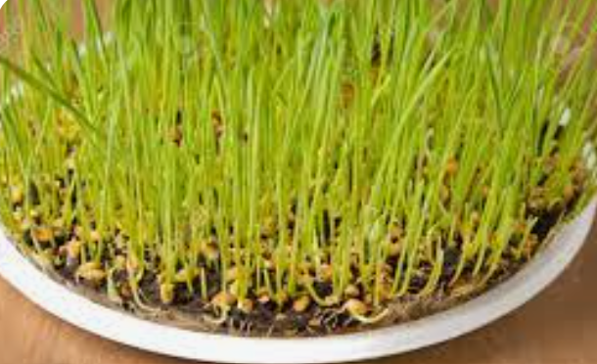

Place in a sunny location.

Keep cotton moist as the seeds begin to sprout.

***EASTER WHEAT SPROUTS***

A traditional Easter activity to remind us of the miracle of Jesus’ resurrection is in this plastic bag. Bring the plate with sprouted wheat to church on Good Friday services on March 29th or Saturday morning, the 30th, at 9 a.m. when Sunday School students and their families take Communion and after have Breakfast together.

Spread the cotton balls out and place on the dish.

Moisten the cotton with water.

Sprinkle the wheat seeds on the moistened cotton balls.

Place in a sunny location.

Keep cotton moist as the seeds begin to sprout.