Communion Sunday Craft

The Joy of a Clean Heart

**Sacrament #2:**

**Penance & Confession of Sin**

**MATERIALS**:

* Construction paper
* Heart template (*to follow*)
* Tissue paper or Wax paper
* Scissors
* Markers
* Stapler

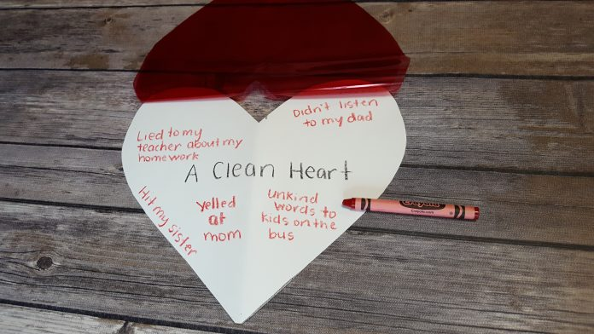

**PREPARATION:**

* Print copies of template
* *Optional*: Cutout hearts from construction paper and tissue/wax paper before class

The red is for His blood

That He shed to forgive sin,

The white is for the water,

Used to baptize newborn skin.

Take my little hand,

hold it as I grow.

Teach me of His love,

and all that love bestows.

**REVIEW**: Penance is the 2nd of the 7 sacraments that a Christian receives in our Armenian Church. The Sacrament of Penance is a great gift from God. Through our priest who hears our confession, God forgives every action or wrongdoing that we may have done. It’s as if God is “cleaning our hearts!” But we have to be truly sorry.

**DIRECTIONS:**

1. Have students cutout 2 hearts the exact same size, *(use template to follow)*:

* 1 heart from construction paper
* the other heart from tissue or wax paper

1. In the center of the construction paper heart, have student write: *“A CLEAN HEART”*

Then, all around *“A CLEAN HEART,”* have students write any “sins” they may have committed, such as: *yelling at a brother or sister, lying, not listening to a parent, saying unkind words, etc.*

1. Staple the tissue/wax paper heart to the top of the construction paper heart. Sin is “lifted” and our hearts are cleaned when we participate in the Sacrament of PENANCE and ask God for forgiveness.