*First Sunday of Lent*

Povn Parygyntan

Poon Pah-reh-gen-tahn

Sunday of Good Living

**GENESIS 2: 2-3**

Thus the heavens and the earth were completed in all their vast array. By the seventh day God had finished the work he had been doing; so on the seventh day he rested from all his work. Then God blessed the seventh day and made it holy, because on it he rested from all the work of creating that he had done.



*Second Sunday of Lent*

P7 Ardaksman Giragi

Ar-dahks-mahn Gee-rah-gee

Sunday of Expulsion

**MATTHEW 5:17-19**

Do not think that I came to destroy the Law or the Prophets. I did not come to destroy but to fulfill. For assuredly, I say to you, ‘till heaven and earth pass away, one jot or one ‘tittle’ will by no means pass from the law ‘till all is fulfilled. Whoever therefore breaks one of the least of these commandments and teaches men so, shall be called least in the kingdom of heaven; but whoever does and teaches *them*, he shall be called great in the kingdom of heaven.



*Third Sunday of Lent*

C7 Ana-agi Giragi

Ah-nah-rrah-gee Gee-rah-gee

Sunday of the Prodigal Son

**LUKE 15:11-32**

It was right that we should make merry and be glad, for your brother was dead and is alive again, and was lost and is found.

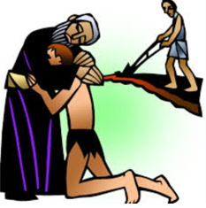

Fourth Sunday of Lent

T7 Dmdysi Giragi

Dun-deh-see Gee-rah-gee

Sunday of the Steward

**LUKE 16:1-13**

No servant can serve two masters; for either he will hate the one and love the other or else he will be loyal to the one and despise the other. You cannot serve God and mammon.

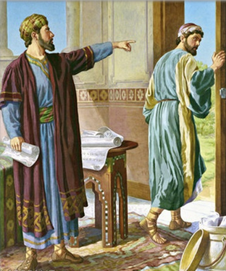

*Fifth Sunday of Lent*

Y7 Tadavori Giragi

Tah-dah-voh-ree Gee-rah-gee

Sunday of the Judge

**LUKE 18:9-14**

I tell you, this man went down to his house justified rather than the other; for everyone who exalts himself will be humbled, and he who humbles himself will be exalted.

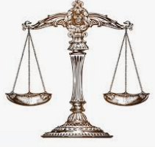

*Sixth Sunday of Lent*

Z7 Calsdyan Giragi

Soorp Kal-us-dyan Gee-rah-gee

Sunday of the Second Coming

**MATTHEW 22:34-38**

You shall love the Lord your God with all your heart, with all your soul, and with all you mind. This is the first and last commandment.

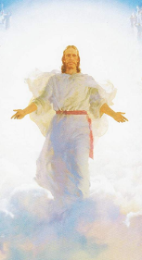

?a.gazart

Dsahgh-gah-zart

Palm Sunday

**Luke 19:28-44**

Then as he was no drawing near the descent of the Mount of Olives, the whole multitude of the disciples began to rejoice and praise God with a loud voice for all the mighty works they had seen, saying: “Blessed is the King who comes in the name of the Lord!”

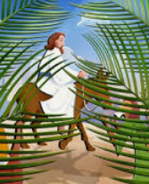

Sovrp Zadig

Soorp Zah-deeg

Holy Easter

**John 20:1-10**

Now on the first day of the week Mary Magdalene went to the tomb early, while it was still dark, and saw *that* the stone had been taken away from the tomb….

