**Sunday School Teachers’ Scripture and Feast Day Weekly Memo**

**Apparition of the Holy Cross**

**From Today’s Readings**

**John 7:14-23** *Jesus is teaching at the Feast of the Tabernacles. When the Jews wonder at how He can be so learned, Jesus cites His source as God the Father and that all who speak out of God’s truth and for His honor are themselves speaking the truth. He criticizes their hypocrisy in condemning a miracle of healing He performed on a Sabbath day (the healing at the pool of Bethesda; see John 5:1-15).* Discussion: Jesus tells the hypocrites of his time: “Stop judging from appearances and make a right judgment.” (v.24) What attitudes in today’s world might elicit this same advice? Have you ever been guilty of judging from appearances rather than God’s standards of right, worth, and value?

**1 John 1:1-10** *The writer gives fervent testimony to the Word of life, having – with other faithful -- seen, heard, and touched Him with their very hands. Jesus is the light and in that light believers are urged to confess their unworthiness and be forgiven, purified, and find fellowship with God and one another.*  Discussion: What two erroneous views we have about ourselves are presented in vv 6 and 8? What beautiful promise counters these in v 7?

**Acts 17:1-15** *In a Thessalonican synagogue, St. Paul teaches the truth of Jesus Christ with reason and passion. His success in bringing many to the faith prompts enemies to incite a mob against his supporters. They are ultimately left unharmed, but Paul and Silas flee to Berea where they again convert a great number. Hostile Jewish leaders once more incite the crowds and the apostles leave for Athens.* Discussion: Since his conversion, Paul’s flight from Berea is the 7th time he had been forced to flee because of his preaching. What difficulties have you experienced in your ministry? How can St. Paul’s persistence serve as an inspiration?

**Apparition of the Holy Cross**

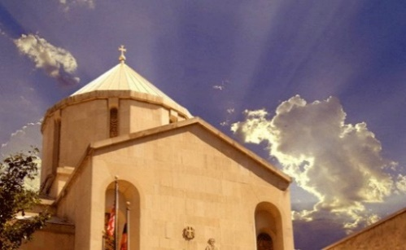The Apparition recalls the astonishing hours on the Feast of Pentecost in 351 A.D. when a blazing cross appeared in the sky extending from Golgotha where Jesus was crucified to the Mount of Olives where He had been arrested. Bishop Cyril of Jerusalem described the miracle in detail in a letter, noting that “The whole city, struck with a reverential fear tempered with joy, ran immediately to the church, young and old, Christians and heathens, citizens and strangers, all with one voice giving praise to our Lord Jesus Christ, the only Son of God, the worker of miracles; finding by experience the truth of the Christian doctrine, to which Heaven bears witness." The milestone anniversary of St. Vartan Cathedral marks yet another kind of miracle. Archbishops Karekin Hovsepian and Tiran Nersoyan planted the dream for a Cathedral that would become spiritual home to Armenians across the Eastern Diocese. Consecrated in 1968 it remains the symbol of Armenian Orthodox presence on American soil and the promise of a new witness in a new world.

*Department of Christian Education*

*Diocese of the Armenian Church (Eastern)* [*elisea@armeniandiocese.org*](mailto:elisea@armeniandiocese.org)