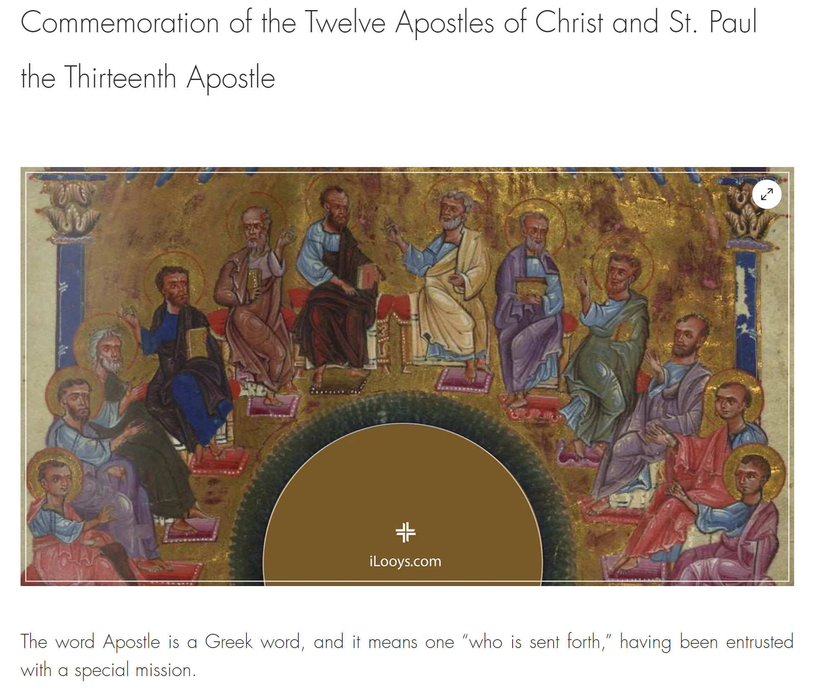

Archbishop Shnork Kaloustian

Vemkar 6/2024

