**Sunday School Teachers’ Scripture and Feast Day Weekly Memo**

**Sunday of Advent**

**From Today’s Readings**

**Matthew 22:34-23:39***In these verses, Jesus summarizes the law in the two greatest commandments (22: 36-40) in which all the law and prophecies of the Old Testament can be summarized. In 23, there is an extended warning (the “seven woes”) against the vanities and false pieties of the Pharisees. The reading concludes with Jesus’ poignant lament for Jerusalem in which (22:37) – in one of the rare moments when a female metaphor for God is used – He yearns to protect its people as a “mother bird gathers her young under her wings.”* Discussion: Why do you think Jesus asks us to love God (22:37) “with all your heart, with all your soul, with all your mind?” What is distinct about each of these three ways of loving?

**Colossians 2:8-3:17** *In a beautiful accompaniment to today’s Gospel, St. Paul urges us to depend on Christ rather than human tradition or worldly principles. Through baptism we have died with Him and are raised with Him into faith and a new way of living. That virtuous, good life is eloquently described in 3:12-17.* Discussion: In 3:9-10 we read that in Christ “you have taken off your old self with its practices and have put on the new self, which is being renewed in knowledge in the image of its Creator.” Comparing the “old” ways described in 3:5-8 with the “new” outlined in 3:12-17, how would you rate yourself? Where do you need more of His help?

**Isaiah 66:1-24**  *Isaiah conveys God’s promise of both restoration and judgment; His children will thrive and be comforted in a new Jerusalem. But those who persist in false worship and rebellion will be harshly judged. Again (as in the Gospel passage above), we are offered a beautiful female image: God will comfort His people as a mother does her child.* Discussion: Isaiah shares these words of God in verse 13: “As a mother comforts her child, so I will comfort you.” God is more often described as a father; what shades of meaning does this picture of God as mother add to your understanding of His love?

**Sunday of the Advent**

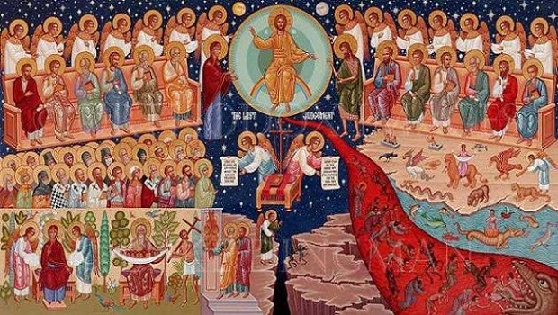This sixth and last Sunday of Lent is dedicated not only to the Second Coming of Christ but also to His Incarnation, that is, God becoming Jesus, fully God and fully human. He will come again -- this time not as a gentle and lowly Savior, but as a righteous judge in the glory of His Father with a retinue of angels. He wll sift through the good and evil just as a shepherd separates the sheep and the goats at day’s end. Jesus declares (Matthew 25:31-46) that we will be judged for acts of righteous goodness born of a loving faith. Did we feed the hungry? Console those in need of comfort, ease suffering? Only on this unequivocal basis, will we be received into eternal life.*Department of Christian Education*

*Diocese of the Armenian Church (Eastern)*

[*elisea@armeniandiocese.org*](mailto:elisea@armeniandiocese.org)