2025-26
St. Peter Armenian Apostolic Church
SUNDAY SCHOOL
17231 Sherman Way • Van Nuys, CA • 91406 • 818-344-4860
stpsundayschool@stpeterarm.org

REGISTRATION FORM

Name of Student: ________________________________________________________________________

Birth Date: _______________Age: ____Grade: ______________Baptized: Yes No Church___________

Name of Student: ________________________________________________________________________

Birth Date: _______________Age: ____Grade: ______________Baptized: Yes No Church___________

Name of Student: ________________________________________________________________________

Birth Date: _______________Age: ____Grade: ______________Baptized: Yes No Church___________

Name of Student: ________________________________________________________________________

Birth Date: _______________Age: ____Grade: ______________Baptized: Yes No Church___________

Street Address: __________________________________________City_______________Zip__________

Father’s Name:___________________________________ Father’s Cell Phone:______________________

Father’s Email:___________________________________________________________________________

Mother’s Name:__________________________________ Mother’s Cell Phone:______________________

Mother’s Email:__________________________________________________________________________

Do you receive St. Peter Church Facebook Posts? YES NO
Special Concerns:Please list and explain any concerns regarding: allergies; dietary or physical restrictions; medical, behavioral, or emotional concerns; learning disorder or anything special that we should be aware of (the information that you provide will assist us in meeting your child’s needs in the classroom and will be kept confidential). ________________________________________________________________________________________
________________________________________________________________________________________
GET Involved! Parental involvement is vital to the success of our school. Please indicate one or more areas you are interested in assisting with:
___Snacks ___Special Events ___Classroom ___Projects ___Luncheons ___Fundraising
***PLEASE TURN FORM OVER AND FILL OUT PARTS 1, 2 AND 3…THANK YOU.***
PART 1 EMERGENCY CONTACT INFORMATION
In the event of an emergency and you cannot be reached, please give the name and number of a relative or friend that we can contact:
Name: _____________________________________________Phone#: __________________________
Relationship: _____________________
**************************************************************************************************************************

PART 2 EMERGENCY MEDICAL AUTHORIZATION

Should it be necessary for my child___________________________ to have emergency medical treatment. I hereby give St. Peter Armenian Church Sunday School Personnel permission(if unable to contact parent) to use their judgment in obtaining medical services for my child and give permission to the physician selected by St. Peter Sunday School personnel to render medical treatment deemed necessary and appropriate by the physician. I understand that St. Peter Sunday School has no insurance. Such medical or hospital costs incurred for my child and any cost incurred for such treatment shall be my responsibility.

Date: _____________Parent’s Signature:_____________________________________________________

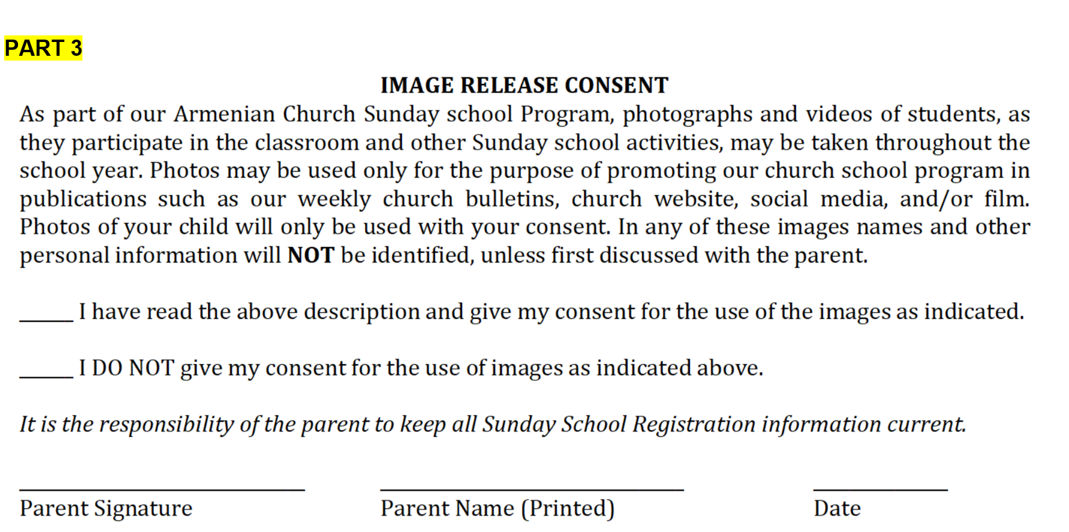

************************************************************************************************************************
FOR OFFICE USE

Registration Date: _________ List Input: ___________ Mail Chimp: __________

