2018-19
Sunday School Calendar
Provided by the Western Diocese Christian Education Council

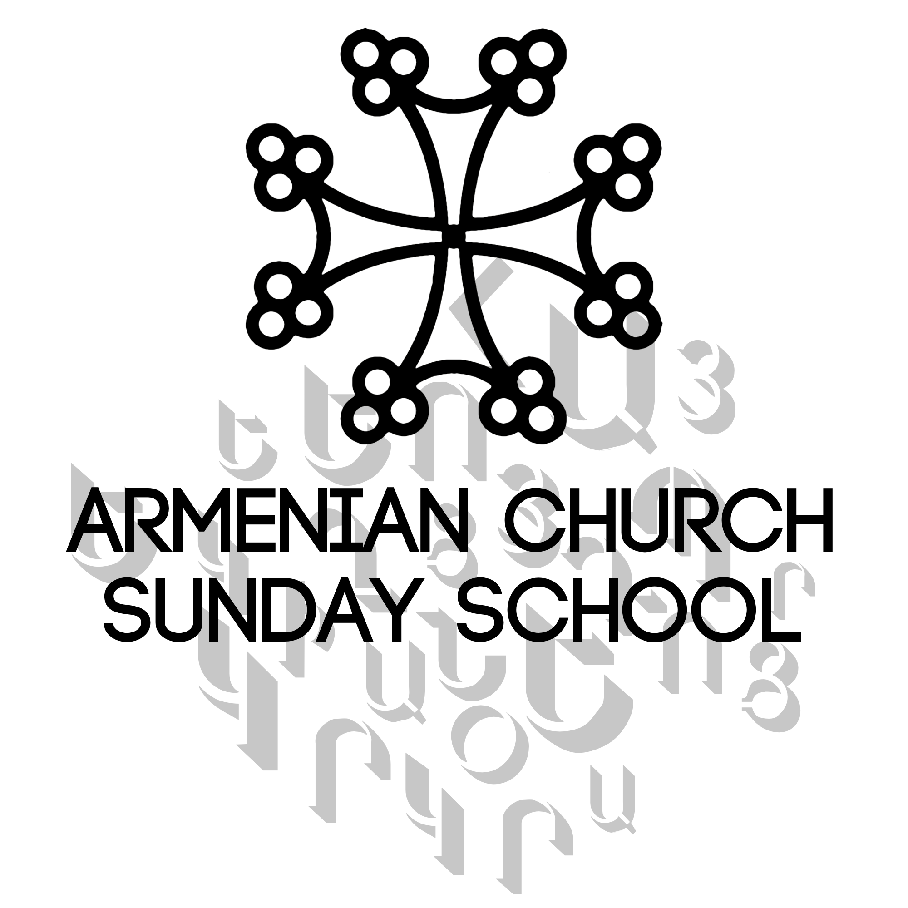

August
18 - CEC Workshop (Central CA-St. Paul, Fresno)
19 - CEC Workshop (Southern CA-St. Peter, Van Nuys)
25 - CEC Workshop (Northern CA-St. John, San Francisco)

September
9 – Registration & 1st day of Sunday school
“Back to School” Meeting/Announcements
16 – School in session
23 – School in session
30 – School in session

October
7 – Children go into church for Communion
Catechetical Sunday
PHOTO DAY!
14 – School in session
21 – School in session
28 – School in session

November
4 – Children go into church for Communion
Daylight Savings – move clock back 1 hour
11 – School in session
18 – School in session
25 – Thanksgiving Vacation – NO SCHOOL

December
2 – Children go into church for Communion
9 – School in session
16 – School in session
23 – School in session
30 – School in session

January
6 – Armenian Christmas
13 – School in session
20 – School in session
27 – School in session



February
3 – Children go into church for Communion
10 – School in session
17 – School in session
24 – School in session

March
3 – Children go into church for Communion “POON PAREGENTAN”
10 – SUNDAY OF EXPULSION - School in session
Daylight Savings – move clock ahead 1 hour
17 – SUNDAY OF PRODIGAL SON - School in session
24 – STEWARD SUNDAY - School in session
31 - SUNDAY OF JUDGE - School in session

April
7 – ADVENT SUNDAY - School in session
14 – PALM SUNDAY - School in session
16 - Holy Maidens service
18 - Maundy Thursday/Washing of Feet service
- - Holy Saturday
21 – EASTER SUNDAY - School in session
24 - Armenian Genocide Memorial Day
28 – School in session (New Sunday)

May
5 – Children go into church for Communion
(Green Sunday)
12 - School in session – Happy Mother’s Day!
(Red Sunday)
19 - Last day of classes
End of School Year Hantes and Luncheon

EVENTS STILL NEEDING TO BE ADDED:
- CEC Advent celebration (at Ararat Home)
- RECLAIM conference
- Lenten Workshop

Prepared by CEC/8-11-18/GC

